**SMART HEALTH CONSULTING ONLINE SYSTEM**

**ABSTRACT :**

The healthcare industry collects huge amounts of healthcare data which, unfortunately, are not “mined” to discover hidden information for effective decision making. Block Chain has been a current trend for attaining diagnostic results. Huge amount of unmined data is collected by the healthcare industry in order to discover hidden information for effective diagnosis and decision making. Block Chain is the process of extracting hidden information from massive dataset, categorizing valid and unique patterns in data. Researchers all over the world are working in either multi agents or in ontologies for developing system in health care domain. It might have happened so many times that you or someone need doctor help but they are not available due to some reason. The health management system is an end user support and online consultation project. Here we propose a system that allows users to get guidance on their health issues through an intelligent health care online system. The objective of our paper is to predict Chronic Kidney Disease (CKD), Heart Disease and Liver Disease using clustering technique, K-means algorithm.

**CHAPTER-1**

**INTRODUCTION**

Smart Health Care Prediction using Block Chain is a new powerful technology which is of high interest in computer world. It is a sub field of computer science that uses already existing data in different database to transform it to new researches and result. The actual task is to extract data by automatic or semi-automatic means. The different parameters included in Block Chain include clustering, forecasting, path analysis and predictive analysis. With the growing researching the field of health informatics a lot of data is being produced. The analysis of such a large amount of data is very hard and requires excessive knowledge. Smart health care applies Block Chain techniques for health diagnosis. Block Chain refers to extracting meaning full information from the different huge amount of dataset. It is the process of determining the unseen finding pattern and knowledge from the massive amount of data set [2].

Block Chain is significant research doings in the field of medical sciences since there is a requirement of wellorganized methodologies for analyzing, predict and detecting diseases. To detect and predict diseases Block Chain applications are used for the management of healthcare, health information, patient care system, etc. It also plays a major role in analyzing survivability of a disease. Block Chain classification techniques play a vital role in healthcare domain by classifying the patient dataset. Block Chain classification technique is used to analyses and predicts many diseases. The classification techniques like Feature selection methods, improve the performance accuracy of the algorithm by reducing the dimensionality of the feature and it can be grouped into a wrapper and filter method. Tendency for Block Chain application in healthcare today is great, because healthcare sector is rich with information, and Block Chain is becoming a necessity. Healthcare organizations produce and collect large volumes of information on daily basis. Use of information technologies allows atomization of processes for extraction of data that help to get interesting knowledge and regularities, which means the elimination of manual tasks and easier extraction of data directly from electronic records, transferring onto secure electronic system of medical records which will save lives and reduce the cost of the healthcare services, as well and early discovery of contagious diseases with the advanced collection of data.

Block Chain can enable healthcare organizations to predict trends in the patient conditions and their behaviors, which is accomplished by data analysis from different perspectives and discovering connections and relations from seemingly unrelated information. Raw data from healthcare organizations are voluminous and heterogeneous. They need to be collected and stored in the organized forms, and their integration enables forming of hospital information system. Healthcare Block Chain provides countless possibilities for hidden pattern investigation from these data sets. These patterns can be used by physicians to determine diagnoses, prognoses and treatments for patients in healthcare organizations. Block Chain has been a current trend for attaining diagnostic results. Huge amount of unmined data is collected by the healthcare industry in order to discover hidden information for effective diagnosis and decision making. Block Chain is the process of extracting hidden information from massive dataset, categorizing valid and unique patterns in data. There are many Block Chain techniques like clustering, classification, association analysis, regression etc. The Health Management system is an end user support and online consultation project. Here we propose a system that allows users to get guidance on their health issues through an intelligent health care system online. Liver failures are at high rate of risk among Indians. The diagnosis of liver disorder at any early stage helps in designing effective prevention measures. In India, one in five persons is affected by liver disease. It is expected that by 2025 India may become the ‘World Capital for Liver Diseases’. The widespread occurrence of liver infection in India is contributed due to deskbound lifestyle, increased alcohol consumption and smoking. There are about 100 types of liver infections. Most prevalent liver infections are cirrhosis, non-alcoholic fatty liver disease and alcoholic liver disease. In the recent years sensors and mobile devices have been used extensively used for rapid detection of an infected liver.Chronic kidney disease (CKD) also called chronic renal failure, which has become a serious problem in the world in which the kidneys are damaged and it is the cause of improper function of kidney organ. The starting date of kidney failure may not be known, it may not recognize as an illness of the patient because it cannot show any symptoms initially. The failure of the kidney can affect the whole human body and it can be a cause of seriously illness and cause of deaths. In chronic kidney disease, the patient’s kidneys are damaged and decrease their functions. If Kidney decrease gets worse, waste can build to high levels in your blood and many complications may develop like high blood pressure, anemia, weak bones, poor nutritional health and nerve damage. In India, the projected number of deaths due to chronic kidney disease was around 5.21 million in 2008 and it is expected to rise to 7.63 million in 2020 (66.7% of all deaths).

Heart disease has become a serious problem in the world in which the heart is damaged and it is the cause of improper function of heart. Life is dependent on competent functioning of heart, because heart is necessary part of our body. If function of heart is not suitable, it will affect the other body parts of human such as brain, kidney etc. Heart disease is a disease that affects on the function of heart. There are number of factors which increases risk of heart disease. At the present days, in the world heart disease is the main cause of deaths. The World Health Organization (WHO) has expected that 12 million deaths occur worldwide, every year due to the heart diseases.

Prediction by using Block Chain techniques gives us accurate result of disease. Smart health prediction system can find out and extract hidden knowledge related with heart disease, kidney disease and liver disease from a historical heart disease, kidney disease and liver disease database. It can answer complex queries for diagnosing the disease and thus help healthcare analysts and practitioners to make intelligent clinical decisions which conventional decision support systems cannot. There is vast potential for Block Chain applications in healthcare. Generally, these can be grouped as the evaluation of treatment effectiveness; management of healthcare; customer relationship management; and detection of fraud and abuse. More specialized medical Block Chain, such as predictive medicine and analysis of DNA microarrays, lies outside the scope of this paper.

Other Block Chain applications related to treatments include associating the various side-effects of treatment, collating common symptoms to aid diagnosis, determining the most effective drug compounds for treating sub populations that respond differently from the mainstream population to certain drugs, and determining proactive steps that can reduce the risk of affliction. The most important aim of this paper is to study the different Block Chain techniques used in prediction of liver, kidney and heart disease by using different Block Chain tools [3].

**Problem statement:**

The current healthcare landscape lacks an efficient and user-friendly online system for smart health consulting, hindering timely access to medical advice. This problem statement aims to address the need for a comprehensive and technologically advanced platform that seamlessly connects users with healthcare professionals, offering personalized and real-time consultations while ensuring data security and compliance with regulatory standards.

**Objectives:**

1. Enhance Accessibility: Develop a user-friendly online platform to provide easy and widespread access to healthcare consultations, overcoming geographical barriers.

2. Personalized Consultations: Implement intelligent algorithms to facilitate personalized health consultations, tailoring advice and recommendations based on individual health data and history.

3. Real-time Interaction: Enable real-time communication between users and healthcare professionals, ensuring timely responses and efficient resolution of health-related queries.

4. Data Security and Compliance: Establish robust security measures to safeguard user health data, ensuring compliance with privacy regulations and building trust in the platform.

5. Integration of Emerging Technologies: Explore and integrate emerging technologies such as AI, machine learning, and telemedicine to enhance the efficiency and effectiveness of health consultations.

6. Seamless Appointment Scheduling: Implement a user-friendly scheduling system for appointments, allowing users to book consultations at their convenience while optimizing healthcare professionals' time.

7. User Education and Empowerment: Provide educational resources within the platform to empower users with knowledge about preventive healthcare, wellness practices, and informed decision-making.

8. Interoperability with Existing Systems: Ensure compatibility and integration with existing healthcare systems to streamline information sharing and promote a cohesive healthcare ecosystem.

9. Feedback Mechanism: Establish a robust feedback mechanism to gather user input and continuously improve the system, addressing any issues promptly and enhancing overall user satisfaction.

10. Scalability: Design the system with scalability in mind to accommodate the growing user base and evolving healthcare needs, ensuring a sustainable and adaptable solution.

**CHAPTER-2**

**LITERATURE SURVEY**

Classification algorithm is one of the greatest significant and applicable Block Chain techniques used to apply in liver, kidney and heart disease prediction. Classification algorithm is the most common in several automatic medical health diagnoses. Many of them show a good classification accuracy listed below

**A: Work related with Liver Disease:**

Prasad proposed “Implementation of Partitional Clustering on ILPD Dataset to Predict Liver Disorder with methods C4.5, NBC in 2016. The result shows NBC algorithm has the highest accuracy [6]. P. Rajeswari, et. al. analyzed the Liver Disorder Using Block Chain Algorithm with Naïve Bayes algorithms, FT tree algorithm , and K Star in 2010. The classification accuracy is found to be better using FT Tree algorithm compare to other algorithms [7]. Noor et.al. have proposed Block Chain Techniques For Optimization of Liver Disease Classification” with Decision Tree, Naive Bayes , and NB Tree algorithm in 2013. The result shows NB Tree algorithm has the highest accuracy; however the Naïve Bayes algorithm gives the fastest computation time [8]. S. Dhamodharan proposed Liver Disease Prediction Using Bayesian Classification” with methods Naïve Bayes and FT tree algorithm in 2014. The result concludes that the accuracy of Naïve Bayes algorithm is much better [9]. Et.ai. have proposed Ensemble Correlation Between Liver Analysis Output with methods KNN, SVM, MLP and decision tree in 2014. The prediction can be correlated and furthermore the correlation can be utilized for detecting the anomaly on the analysis [10]. S. Annesh Kumar et. al. have proposed” A novel approach for Liver disorder Classification using Block Chain Techniques” with methods Fuzzy, Kmeans classification in 2015. Fuzzy based classification gives better performance and achieved above 94% accuracy for each type of liver disorder [11]. Thangarajul, et. al. have analyzed the performance of PSO- K Star Classifier Over Liver Diseases ”with methods PSO with K Star classification in 2015. PSO-K star algorithm is best suitable algorithm for the classification of liver disorders as it improved the performance in prediction accuracy [12]. Gregory et. al. have propose Prediction of Liver Disease (Biliary Cirrhosis) Using Block Chain Technique with method FT Tree algorithm in 2015. The classification accuracy is found to be better using FT Tree algorithm [13].Vijayarani et. al. have proposed Liver Disease Prediction using Block Chain Technique with method Naïve Bayes SVM in 2015. The SVM classifier is considered as a best classification algorithm [14]. Ebenezer et. al. have proposed the Liver Disease Diagnosis Based on Neural Networks ”with methodsC4.5, CART, Naïve Bayes, SVM in 2015. SVM is the optimal model as it gives more accurate result than other algorithms [15]. Baitharua et. al. have analyzed the Block Chain Techniques For Healthcare Decision Support System Using Liver Disorder Dataset with methodsJ.48, SVM, Random Forest in 2016.

By analysing the results Random Forest gives the overall best classification result [16]. Gulia et. al have proposed the Liver Patient Classification Using Intelligent Techniques ”with methods SVM, Random Forest in 2014. The results indicate that Random Forest algorithm outperformed all other techniques with the help of feature selection [17].

**B: Work related with Chronic Kidney Disease:**

S. Ramya et. al. have diagnosis the Chronic Kidney Disease Using Machine Learning Algorithms” with methods Random Forest ,Back Propagation ,Radial Basis Function in 2016.The results indicate that Random Forest algorithm outperformed all other techniques with the help of feature selection[18]. Lambodar Jena et. al. have applied Distributed Block Chain Classification Algorithms for Prediction of Chronic-Kidney Disease with methods Naïve Bayes ,Multilayer Perceptron, SVM, J48, Conjuctive rule, Decision tree in 2015. The SVM classifier is considered as a best classification algorithm[19]. Vijayaran et. al. have proposed Kidney disease Prediction Using SVM and ANN Algorithm with methods SVM and ANN in 2015.The SVM classifier is considered as a best classification algorithm because of its highest classification accuracy values[20]. ParulSinha et. al. have Comparative Study of Chronic Kidney Disease Prediction using SVM in 2015.The result shows SVM algorithm has the highest accuracy [21].Manish Kumar proposed Prediction of Chronic Kidney Disease Using Random Forest Machine Learning Algorithm with Random forest, Sequential minimal optimization, Naïve Bayes, Radial basis function, Multilayer perception methods in 2016. Naïve Bayes algorithm is best suitable algorithm for the classification of kidney disorders as it improved the performance in prediction accuracy [22]. Abheer et. al. have proposed Diagnosis and Classification of Chronic Renal Failure Utilising Intelligent Block Chain Classifiers with method Decision tree in 2014. This is the most effective model to predict patients with kidney disease [23]. Kousal Kumar et. al. have proposed Artificial Neural Networks for Diagnosis of Kidney Stones Diseases with Radial Basis Function, Multilayer Perceptron and Learning Vector Quantization methods in 2012. Radial Basis Function gives better performance and achieved above 94% accuracy for each type of kidney disorder [24]. K. R. Laxmi et. al. have Performance Comparison of Three Block Chain Techniques For Predicting Kidney Dialysis Survivability with methods ANN, Decision tree and Logistic regression in 2014. The classification accuracy is found to be better using Decision Tree algorithm compare to other algorithms [25]. Kaladhar et. al. have proposed Statistical and Block Chain Aspects on Kidney Stones: A Systematic Review and Metaanalysis with methods Naïve Bayes, Logistic regression, Random Forest and J48 in 2012. The classification accuracy is found to be better using Naïve Bayes algorithm compared to other algorithms [26]. Veenita proposed” Chronic Kidney Disease Analysis Using Block Chain Classification Technique with method Naïve Bayes Artificial Neural Network in 2016. The classification accuracy is found to be better Naïve Bayes [27].

**C: Work related with Heart Disease:**

Roohallah proposed” A Block Chain approach for diagnosis of coronary artery disease with methods SVM, NBC, ANN and Bagging Algorithm in 2013.This research investigates applying a range of techniques to different types of Decision Trees seeking better performance in heart disease diagnosis [28]. Randa proposed” Feature Analysis of Coronary Artery Heart Disease Data Sets Elsevier, International with method C4.5in 2015.

This is the most effective model to predict patients with heart disease[29]. M.khil proposed Classification of Heart Disease Using K-Nearest Neighbour and Genetic Algorithm with methods KNN, Genetic algorithm in 2013. KNN is more accurate than genetic algorithm [30].Y. Alp et. al. have proposed Evidence Combination in Medical Block Chain with methods KNN, Naïve Bayesian and Decision Tree in 2004.Naïve Bayes algorithm gives the fastest computation time[31]. Franck Le Duff proposed Predicting Survival Causes After Out of Hospital Cardiac Arrest using Block Chain Method with method NB tree in 2004.NB tree algorithm has the highest accuracy[32].Boleslaw Szymanski proposed Using Efficient Supanova Kernel For Heart Disease Diagnosis with method SVM in 2006.The result shows SVM algorithm has the highest accuracy[33]. HeonGyu Lee proposed Mining Bio-Signal Data: Coronary Artery Disease Diagnosis using Linear and Nonlinear Features of HRV with methods Bayesian classifiers, CMAR, Decision Tree and SVM in 2007.The SVM classifier is considered as a best classification algorithm because of its highest classification accuracy values [34]. Niti Guru proposed Decision Support System for Heart Disease Diagnosis Using Neural Network with method Neural Networkin 2007. In this paper proposed the prediction of Heart disease, Blood Pressure and Sugar with the aid of Neural networks [35]. Sellappan Palaniappan proposed Intelligent Heart Disease Prediction System Using Block Chain Techniques with methods Decision Trees, Naïve Bayes and Neural Network in 2008.It is user friendly, web based, scalable, reliable and expandable [36]. LathaParthiban proposed” Intelligent Heart Disease Prediction System using CANFIS and Genetic Algorithm with methods CANFIS and Genetic Algorithm in 2008. The CANFIS model is shown the potential in the prediction of the heart disease as illustrated by the result [37]. HaiWang proposed” Medical Knowledge Acquisition through Block Chain with method KNN in 2008. This paper presents a model of medical knowledge acquisition through Block Chain [38].

**CHAPTER – 3**

**SYSTEM ANALYSIS**

**EXISTING SYSTEM :**

The rate of kidney, liver and heart diseases is increasing at an exponential rate. The busy lifestyle of people in this era with all the fast food in the lunch break and getting back to sitting and working has pushed as over the edge. Along with this people today have a lack of exercise and are less active. For most of them recreation is just another movie in bed or anything technology based. Physical activities have reduced drastically. These factors boosted the rate of kidney, liver and heart diseases to an unfortunately high percentage. In a developing country like ours the rate of heart diseases has the same effect. The annual mortality rate per 100,000 people from cardiovascular diseases in Bangladesh has increased by 128.9% since 1990, an average of 5.6% a year. Prediction of heart diseases is a difficult and risky task. Since it is directly dependent on people's’ health, accuracy is a major factor. If not predicted accurately it can be disastrous. This research therefore focuses on the comparison of different Block Chain techniques to predict it.

**DISADVANTAGES OF EXISTING SYSTEM :**

1) Less accuracy

2)low Efficiency

**PROPOSED SYSTEM :**

The proposed system aims at presenting the end users a personalized health-care system with help of Block Chain. In the proposed method we use the concepts of fitness number. In the proposed approach we convert the given data set into binary format as per the given condition for liver, kidney and heart disease. We divide the large data set into number of parts. We perform simple intersection calculation for every part of data set and finally we consider only those item set which satisfy the given minimum support fitness value. Disease Classification Method:

In this work, the comparison of feature selections to classify dataset is presented. The dataset is gathered from a famous travel UCI WEB Repository and kaggle

Overview of research framework constitutes the five main steps:

1) Data Collection: collected disease data from a data set providing website

2) Feature Extraction: Main purpose of the second step is to transform the dataset in the database into a format suitable for Block Chain by extracting and reducing terms from text

3) Feature Selection: There are large amount of extracted features from the feature extraction step. If classification models are created with all of them, they could give a lowaccurate classification result on a test dataset, which is the effect known as over fitting.

4) Classification: The selected features of training and test sets are transformed into a document matrix. Then only the document matrix of training set is used to create models with classification algorithms. The purpose of the fourth step is selecting the best algorithm for classifying the disease dataset

5) Models’ Performance Evaluation: After the classification models were built. They are used to evaluate their performance in the fifth step. The document matrix of test set from the previous step is taken to evaluate with the models. The performance evaluation is considered both number of features and accuracy of models. The proposed system has 3 options which will predict 3 different health issue. The system predicts whether the user’s heart, kidney or liver are healthy or not. The user has to provide input to the system. The system then predicts user’s health according to the user’s data provided by comparing it with the dataset provided using KNN algorithm.

**ADVANTAGES OF PROPOSED SYSTEM :**

1) High accuracy

2)High efficiency

**Project Requirements**

The project involved analyzing the design of few applications so as to make the application more users friendly. To do so, it was really important to keep the navigations from one screen to the other well ordered and at the same time reducing the amount of typing the user needs to do. In order to make the application more accessible, the browser version had to be chosen so that it is compatible with most of the Browsers.

**Functional Requirements**

* Graphical User interface with the User.

**Non Functional Requirements**

• **Maintainability:** Maintainability is used to make future maintenance easier, meet new requirements. Our project can support expansion.

• **Robustness:** Robustness is the quality of being able to withstand stress, pressures or changes in procedure or circumstance. Our project also provides it.

• **Reliability:** Reliability is an ability of a person or system to perform and maintain its functions in circumstances. Our project also provides it.

• **Size:** The size of a particular application plays a major role, if the size is less then efficiency will be high. The size of database we have developed is 5.05 MB.

• **Speed:** If the speed is high then it is good. Since the no of lines in our code is less, hence the speed is high.

• **Power Consumption:** In battery-powered systems, power consumption is very important. In the requirement stage, power can be specified in terms of battery life.

However the allowable wattage can’t be defined by the customer. Since the no of lines

of code is less CPU uses less time to execute hence power usage will be less.

**HARDWARE & SOFTWARE REQUIREMENTS:**

**HARD REQUIRMENTS :**

* System    :   i3 or above.
* Ram    :   4 GB.
* Hard Disk : 40 GB

**SOFTWARE REQUIRMENTS :**

* Operating system   : Windows8 or Above.
* Coding Language  : python

**CHAPTER – 4**

**SYSTEM DESIGN**

**SYSTEM ARCHITECTURE :**

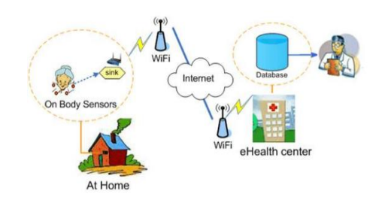

Prediction by using data mining techniques gives us accurate result of disease. Smart health prediction system can find out and extract hidden knowledge related with heart disease, kidney disease and liver disease from a historical heart disease, kidney disease and liver disease database. It can answer complex queries for diagnosing the disease and thus help healthcare analysts and practitioners to make intelligent clinical decisions which conventional decision support systems cannot. There is vast potential for data mining applications in healthcare. Generally, these can be grouped as the evaluation of treatment effectiveness; management of healthcare; customer relationship management; and detection of fraud and abuse. More specialized medical data mining, such as predictive medicine and analysis of DNA microarrays, lies outside the scope of this paper.

**DEATIED DESIGN**

**BLOCK DIGRAM**

# C:\Users\Lenovo\Downloads\WhatsApp Image 2024-01-19 at 4.25.45 PM.jpeg

**UML Diagrams**

UML stands for Unified Modeling Language. UML is a standardized general-purpose modeling language in the field of object-oriented software engineering. The standard is managed, and was created by, the Object Management Group.

The goal is for UML to become a common language for creating models of object oriented computer software. In its current form UML is comprised of two major components: a Meta-model and a notation. In the future, some form of method or process may also be added to; or associated with, UML.

The Unified Modeling Language is a standard language for specifying, Visualization, Constructing and documenting the artifacts of software system, as well as for business modeling and other non-software systems.

The UML represents a collection of best engineering practices that have proven successful in the modeling of large and complex systems.

The UML is a very important part of developing objects oriented software and the software development process. The UML uses mostly graphical notations to express the design of software projects.

**GOALS:**

The Primary goals in the design of the UML are as follows:

1. Provide users a ready-to-use, expressive visual modeling Language so that they can develop and exchange meaningful models.
2. Provide extendibility and specialization mechanisms to extend the core concepts.
3. Be independent of particular programming languages and development process.
4. Provide a formal basis for understanding the modeling language.
5. Encourage the growth of OO tools market.
6. Support higher level development concepts such as collaborations, frameworks, patterns and components.

7. Integrate best practices.

**DATA FLOW DIAGRAM:**

1. The DFD is also called as bubble chart. It is a simple graphical formalism that can be used to represent a system in terms of input data to the system, various processing carried out on this data, and the output data is generated by this system.

2. The data flow diagram (DFD) is one of the most important modeling tools. It is used to model the system components. These components are the system process, the data used by the process, an external entity that interacts with the system and the information flows in the system.

3. DFD shows how the information moves through the system and how it is modified by a series of transformations. It is a graphical technique that depicts information flow and the transformations that are applied as data moves from input to output.

4. DFD is also known as bubble chart. A DFD may be used to represent a system at any level of abstraction. DFD may be partitioned into levels that represent increasing information flow and functional detail

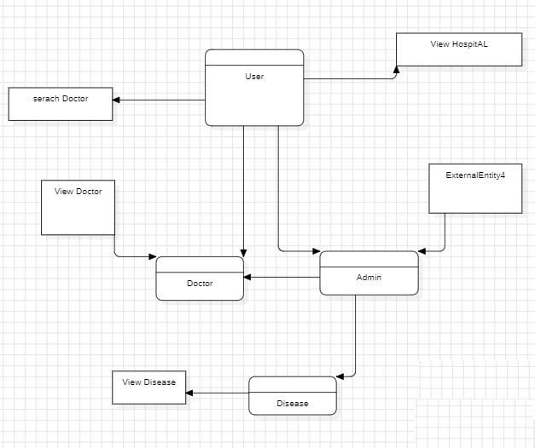

**USE CASE DIAGRAM:**

A use case diagram in the Unified Modeling Language (UML) is a type of behavioral diagram defined by and created from a Use-case analysis. Its purpose is to present a graphical overview of the functionality provided by a system in terms of actors, their goals (represented as use cases), and any dependencies between those use cases. The main purpose of a use case diagram is to show what system functions are performed for which actor. Roles of the actors in the system can be depicted.

   

# CLASS DIAGRAM:

In software engineering, a class diagram in the Unified Modeling Language (UML) is a type of static structure diagram that describes the structure of a system by showing the system's classes, their attributes, operations (or methods), and the relationships among the classes. It explains which class contains information.

 

**SEQUENCE DIAGRAM:**

A sequence diagram in Unified Modeling Language (UML) is a kind of interaction diagram that shows how processes operate with one another and in what order. It is a construct of a Message Sequence Chart. Sequence diagrams are sometimes called event diagrams, event scenarios, and timing diagrams.



**ACTIVITY DIAGRAM**

Activity diagrams are graphical representations of workflows of stepwise activities and actions with support for choice, iteration and concurrency. In the Unified Modeling Language, activity diagrams can be used to describe the business and operational step-by-step workflows of components in a system. An activity diagram shows the overall flow of control.

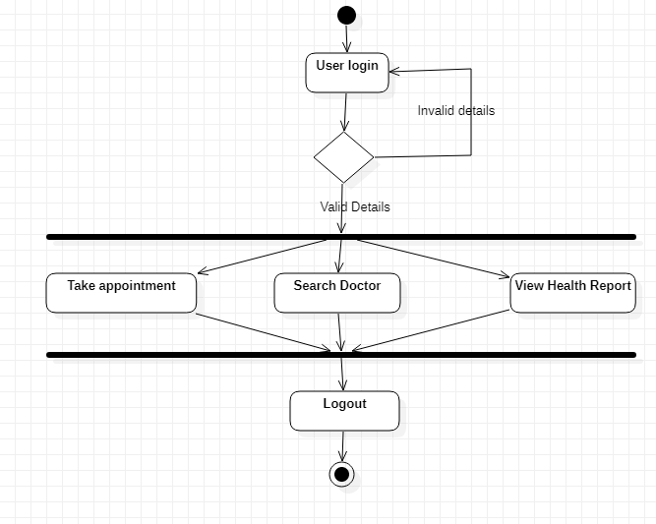

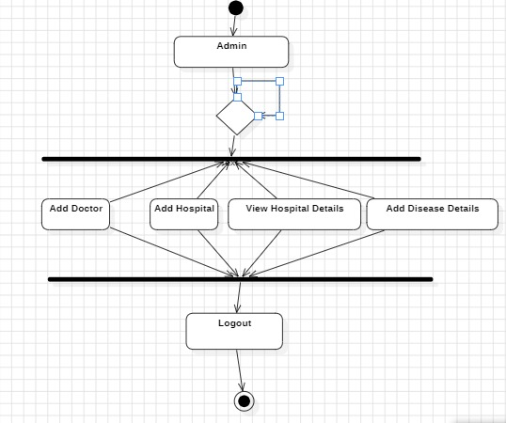

**COLLABRATION DIAGRAM:**



**State Chat diagram:**

A state diagram, as the name suggests, represents the different states that objects in the system undergo during their life cycle. Objects in the system change states in response to events. In addition to this, a state diagram also captures the transition of the object's state from an initial state to a final state in response to events affecting the system.

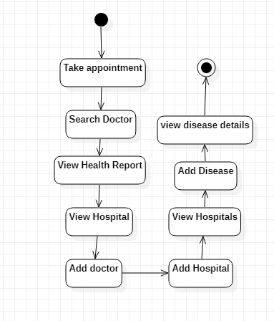

**CHAPTER – 5**

**MODULES DESCRIPTION**

**MODULES:**

1. Admin: admin can login to application by using username and password as ‘admin’ and ‘admin’. After login admin will add doctors and hospital details and can add disease details, medicine and symptoms details.
2. Doctor: doctor can login to application by using username and password given by admin and then can view all appointments from patients and prescribe medicines
3. Patient: patients can signup with the application and then login and then search disease and its medicine details and can take appointments and can view prescription from doctors.

**CHAPTER – 6**

**TECHNOLOGY DESCRIPTION**

Python is a general-purpose interpreted, interactive, object-oriented, and high-level programming language. An [interpreted language](https://en.wikipedia.org/wiki/Interpreted_language), Python has a design philosophy that emphasizes code [readability](https://en.wikipedia.org/wiki/Readability) (notably using [whitespace](https://en.wikipedia.org/wiki/Whitespace_character) indentation to delimit [code blocks](https://en.wikipedia.org/wiki/Code_block) rather than curly brackets or keywords), and a syntax that allows programmers to express concepts in fewer [lines of code](https://en.wikipedia.org/wiki/Source_lines_of_code) than might be used in languages such as [C++](https://en.wikipedia.org/wiki/C%2B%2B)or [Java](https://en.wikipedia.org/wiki/Java_(programming_language)). It provides constructs that enable clear programming on both small and large scales. Python interpreters are available for many [operating systems](https://en.wikipedia.org/wiki/Operating_system). [CPython](https://en.wikipedia.org/wiki/CPython" \o "CPython), the [reference implementation](https://en.wikipedia.org/wiki/Reference_implementation) of Python, is [open source](https://en.wikipedia.org/wiki/Open_source) software and has a community-based development model, as do nearly all of its variant implementations. CPython is managed by the non-profit [Python Software Foundation](https://en.wikipedia.org/wiki/Python_Software_Foundation). Python features a [dynamic type](https://en.wikipedia.org/wiki/Dynamic_type) system and automatic [memory management](https://en.wikipedia.org/wiki/Memory_management). It supports multiple [programming paradigms](https://en.wikipedia.org/wiki/Programming_paradigm), including [object-oriented](https://en.wikipedia.org/wiki/Object-oriented_programming), [imperative](https://en.wikipedia.org/wiki/Imperative_programming), [functional](https://en.wikipedia.org/wiki/Functional_programming) and [procedural](https://en.wikipedia.org/wiki/Procedural_programming), and has a large and comprehensive [standard library](https://en.wikipedia.org/wiki/Standard_library)

## What is Python

## Python is a popular programming language. It was created by Guido van Rossum, and released in 1991.

**It is used for:**

* web development (server-side),
* software development,
* mathematics,
* system scripting.

### What can Python do

* Python can be used on a server to create web applications.
* Python can be used alongside software to create workflows.
* Python can connect to database systems. It can also read and modify files.
* Python can be used to handle big data and perform complex mathematics.
* Python can be used for rapid prototyping, or for production-ready software development.

### Why Python

* Python works on different platforms (Windows, Mac, Linux, Raspberry Pi, etc).
* Python has a simple syntax similar to the English language.
* Python has syntax that allows developers to write programs with fewer lines than some other programming languages.
* Python runs on an interpreter system, meaning that code can be executed as soon as it is written. This means that prototyping can be very quick.
* Python can be treated in a procedural way, an object-orientated way or a functional way.

### Good to know

* The most recent major version of Python is Python 3, which we shall be using in this tutorial. However, Python 2, although not being updated with anything other than security updates, is still quite popular.
* In this tutorial Python will be written in a text editor. It is possible to write Python in an Integrated Development Environment, such as Thonny, Pycharm, Netbeans or Eclipse which are particularly useful when managing larger collections of Python files.

### Python Syntax compared to other programming languages

* Python was designed for readability, and has some similarities to the English language with influence from mathematics.
* Python uses new lines to complete a command, as opposed to other programming languages which often use semicolons or parentheses.
* Python relies on indentation, using whitespace, to define scope; such as the scope of loops, functions and classes. Other programming languages often use curly-brackets for this purpose.

**Introduction**

Python applications will often use packages and modules that don’t come as part of the standard library. Applications will sometimes need a specific version of a library, because the application may require that a particular bug has been fixed or the application may be written using an obsolete version of the library’s interface.

This means it may not be possible for one Python installation to meet the requirements of every application. If application A needs version 1.0 of a particular module but application B needs version 2.0, then the requirements are in conflict and installing either version 1.0 or 2.0 will leave one application unable to run.

The solution for this problem is to create a virtual environment, a self-contained directory tree that contains a Python installation for a particular version of Python, plus a number of additional packages.

Different applications can then use different virtual environments. To resolve the earlier example of conflicting requirements, application A can have its own virtual environment with version 1.0 installed while application B has another virtual environment with version 2.0. If application B requires a library be upgraded to version 3.0, this will not affect application A’s environment.

**Creating Virtual Environments**

The module used to create and manage virtual environments is called venv. venv will usually install the most recent version of Python that you have available. If you have multiple versions of Python on your system, you can select a specific Python version by running python3 or whichever version you want.

To create a virtual environment, decide upon a directory where you want to place it, and run the venv module as a script with the directory path:

python3 -m venv tutorial-env

This will create the tutorial-env directory if it doesn’t exist, and also create directories inside it containing a copy of the Python interpreter, the standard library, and various supporting files.

A common directory location for a virtual environment is .venv. This name keeps the directory typically hidden in your shell and thus out of the way while giving it a name that explains why the directory exists. It also prevents clashing with .env environment variable definition files that some tooling supports.

Once you’ve created a virtual environment, you may activate it.

On Windows, run:

tutorial-env\Scripts\activate.bat

On Unix or MacOS, run:

source tutorial-env/bin/activate

(This script is written for the bash shell. If you use the csh or fish shells, there are alternate activate.csh and activate.fish scripts you should use instead.)

Activating the virtual environment will change your shell’s prompt to show what virtual environment you’re using, and modify the environment so that running python will get you that particular version and installation of Python. For example:

$ source ~/envs/tutorial-env/bin/activate

(tutorial-env) $ python

Python 3.5.1 (default, May 6 2016, 10:59:36)

>>> import sys

>>>sys.path

['', '/usr/local/lib/python35.zip', ...,

'~/envs/tutorial-env/lib/python3.5/site-packages']

>>>

Managing Packages with pip

You can install, upgrade, and remove packages using a program called pip. By default pip will install packages from the Python Package Index, <https://pypi.org>. You can browse the Python Package Index by going to it in your web browser, or you can use pip’s limited search feature:

(tutorial-env) $ pip search astronomy

skyfield - Elegant astronomy for Python

gary - Galactic astronomy and gravitational dynamics.

novas - The United States Naval Observatory NOVAS astronomy library

astroobs - Provides astronomy ephemeris to plan telescope observations

PyAstronomy - A collection of astronomy related tools for Python.

...

pip has a number of subcommands: “search”, “install”, “uninstall”, “freeze”, etc. (Consult the Installing Python Modules guide for complete documentation for pip.)

You can install the latest version of a package by specifying a package’s name:

(tutorial-env) $ pip install novas

Collecting novas

Downloading novas-3.1.1.3.tar.gz (136kB)

Installing collected packages: novas

Running setup.py install for novas

Successfully installed novas-3.1.1.3

You can also install a specific version of a package by giving the package name followed by == and the version number:

(tutorial-env) $ pip install requests==2.6.0

Collecting requests==2.6.0

Using cached requests-2.6.0-py2.py3-none-any.whl

Installing collected packages: requests

Successfully installed requests-2.6.0

If you re-run this command, pip will notice that the requested version is already installed and do nothing. You can supply a different version number to get that version, or you can run pip install --upgrade to upgrade the package to the latest version:

(tutorial-env) $ pip install --upgrade requests

Collecting requests

Installing collected packages: requests

Found existing installation: requests 2.6.0

Uninstalling requests-2.6.0:

Successfully uninstalled requests-2.6.0

Successfully installed requests-2.7.0

pip uninstall followed by one or more package names will remove the packages from the virtual environment.

distribution taken from the supported_dists parameter.

Deprecated since version 2.6.

platform.linux_distribution(distname='', version='', id='', supported_dists=('SuSE', 'debian', 'redhat', 'mandrake', ...), full_distribution_name=1)

Tries to determine the name of the Linux OS distribution name.

**2. Using the Python Interpreter**

**2.1. Invoking the Interpreter**

The Python interpreter is usually installed as /usr/local/bin/python3.8 on those machines where it is available; putting /usr/local/bin in your Unix shell’s search path makes it possible to start it by typing the command:

python3.8

to the shell. 1 Since the choice of the directory where the interpreter lives is an installation option, other places are possible; check with your local Python guru or system administrator. (E.g., /usr/local/python is a popular alternative location.)

On Windows machines where you have installed Python from the Microsoft Store, the python3.8 command will be available. If you have the py.exe launcher installed, you can use the py command. See Excursus: Setting environment variables for other ways to launch Python.

Typing an end-of-file character (Control-D on Unix, Control-Z on Windows) at the primary prompt causes the interpreter to exit with a zero exit status. If that doesn’t work, you can exit the interpreter by typing the following command: quit().

The interpreter’s line-editing features include interactive editing, history substitution and code completion on systems that support the GNU Readline library. Perhaps the quickest check to see whether command line editing is supported is typing Control-P to the first Python prompt you get. If it beeps, you have command line editing; see Appendix Interactive Input Editing and History Substitution for an introduction to the keys. If nothing appears to happen, or if ^P is echoed, command line editing isn’t available; you’ll only be able to use backspace to remove characters from the current line.

The interpreter operates somewhat like the Unix shell: when called with standard input connected to a tty device, it reads and executes commands interactively; when called with a file name argument or with a file as standard input, it reads and executes a script from that file.

A second way of starting the interpreter is python -c command [arg] ..., which executes the statement(s) in command, analogous to the shell’s -c option. Since Python statements often contain spaces or other characters that are special to the shell, it is usually advised to quote command in its entirety with single quotes.

Some Python modules are also useful as scripts. These can be invoked using python -m module [arg] ..., which executes the source file for module as if you had spelled out its full name on the command line.

When a script file is used, it is sometimes useful to be able to run the script and enter interactive mode afterwards. This can be done by passing -i before the script.

All command line options are described in Command line and environment.

Argument Passing

When known to the interpreter, the script name and additional arguments thereafter are turned into a list of strings and assigned to the argv variable in the sys module. You can access this list by executing import sys. The length of the list is at least one; when no script and no arguments are given, sys.argv[0] is an empty string. When the script name is given as '-' (meaning standard input), sys.argv[0] is set to '-'. When -c command is used, sys.argv[0] is set to '-c'. When -m module is used, sys.argv[0] is set to the full name of the located module. Options found after -c command or -m module are not consumed by the Python interpreter’s option processing but left in sys.argv for the command or module to handle.

Interactive Mode

When commands are read from a tty, the interpreter is said to be in interactive mode. In this mode it prompts for the next command with the primary prompt, usually three greater-than signs (>>>); for continuation lines it prompts with the secondary prompt, by default three dots (...). The interpreter prints a welcome message stating its version number and a copyright notice before printing the first prompt:

$ python3.8

Python 3.8 (default, Sep 16 2015, 09:25:04)

[GCC 4.8.2] on linux

Type "help", "copyright", "credits" or "license" for more information.

>>>

**2.2. The Interpreter and Its Environment**

**2.2.1. Source Code Encoding**

By default, Python source files are treated as encoded in UTF-8. In that encoding, characters of most languages in the world can be used simultaneously in string literals, identifiers and comments — although the standard library only uses ASCII characters for identifiers, a convention that any portable code should follow. To display all these characters properly, your editor must recognize that the file is UTF-8, and it must use a font that supports all the characters in the file.

To declare an encoding other than the default one, a special comment line should be added as the first line of the file. The syntax is as follows:

# -*- coding: encoding -*-

where encoding is one of the valid codecs supported by Python.

For example, to declare that Windows-1252 encoding is to be used, the first line of your source code file should be:

# -*- coding: cp1252 -*-

One exception to the first line rule is when the source code starts with a UNIX “shebang” line. In this case, the encoding declaration should be added as the second line of the file. For example:

#!/usr/bin/env python3

# -*- coding: cp1252 -*-

**6.2 Packages and Versions**

astunparse ==1.6.3

certifi ==2022.12.7

charset-normalizer ==3.0.1

contourpy ==1.0.7

cycler ==0.11.0

Django ==3.0.4

et-xmlfile ==1.1.0

fonttools ==4.38.0

gast ==0.3.3

google-pasta ==0.2.0

grpcio ==1.51.1

h5py ==2.10.0

idna ==3.4

importlib-metadata ==6.0.0

joblib ==1.2.0

Keras ==2.3.1

Keras-Applications ==1.0.8

Keras-Preprocessing ==1.1.2

kiwisolver ==1.4.4

Markdown ==3.4.1

matplotlib ==3.6.3

mysql-connector-python ==8.0.32

mysqlclient ==2.1.1

numpy ==1.21.4

oauthlib ==3.2.2

openpyxl ==3.1.0

opt-einsum ==3.3.0

packaging ==23.0

pandas ==1.3.5

Pillow ==9.4.0

pip ==20.1.1

protobuf ==3.20.3

pyparsing ==3.0.9

opencv-contrib-python 4.5.2.52

**CHAPTER – 7**

Now-a-days all peoples are leaving stressful life because of competition in every fields such as working area, learning area etc. Stressful life fetch many health problems which require frequent visiting of doctors and sometime doctors may not be available for consultation and this may degrade patient health further and to overcome from this problem we are designing SMART Health Consulting System which can helps patients in diagnosing their disease and prescribe related medicines. Patients can take online appointment and can visit doctor for medication.

To secure patients data we are using Blockchain technology for storage and this Blockchain store each data as block/transaction and associate each block with unique hashcode and while storing new records Blockchain will verify hashcode of all previous blocks and if hashcode matches then data is secured and not alter by hacker or hospital internal employees. Due to this verification Blockchain data is called as immutable or tamper proof.

**SCREEN SHOTS**

To store data in Blockchain we need to design SMART CONTRACT which contains functions to store and retrieve details from Blockchain. We have designed following Contract for this project.

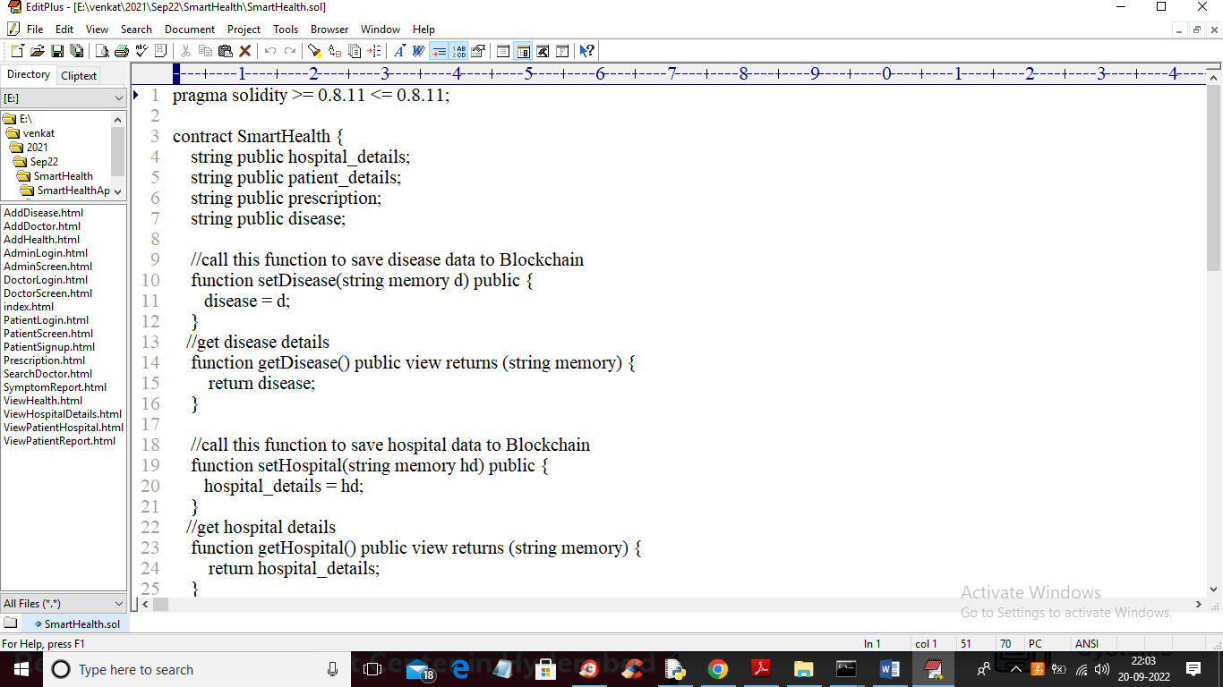

In above Smart Contract screen for different data storage we have defined different Blockchain functions and to deploy this contract on Blockchain Ethereum tool we need to follow below steps

1. Go inside ‘hello-eth/node_modules/bin’ folder and then double click on ‘runBlockchain.bat’ file to start Ethereum tool and get below screen

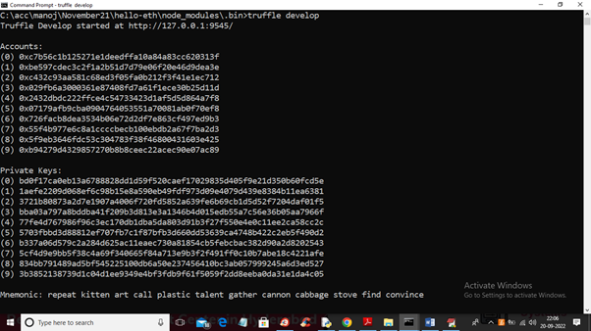

1. In above screen Ethereum generated some default account and private keys and now type command as ‘truffle migrate’ and press enter key to deploy contract and get below contract address

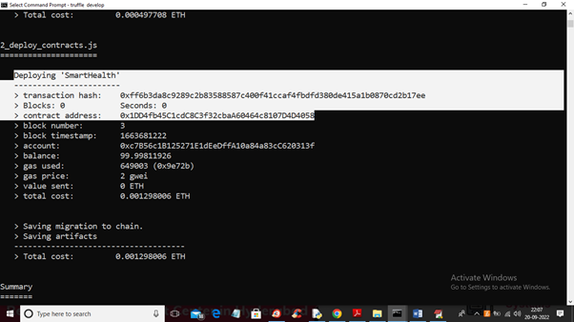

1. In above screen in white colour text we can see ‘SmartHealth’ contract deployed and we got contract address also and this address we need to specify in python program to store and read data from Blockchain. In below screen showing python code calling Blockchain Smart contract

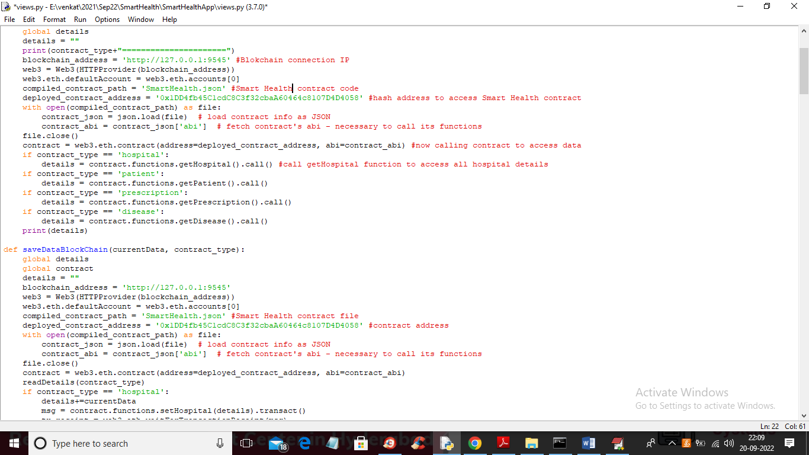

1. In above screen read red colour comments to know about Smart Contract calling from python code. Now contract deployed and now double click on ‘run.bat’ file to start python Django web server and get below screen

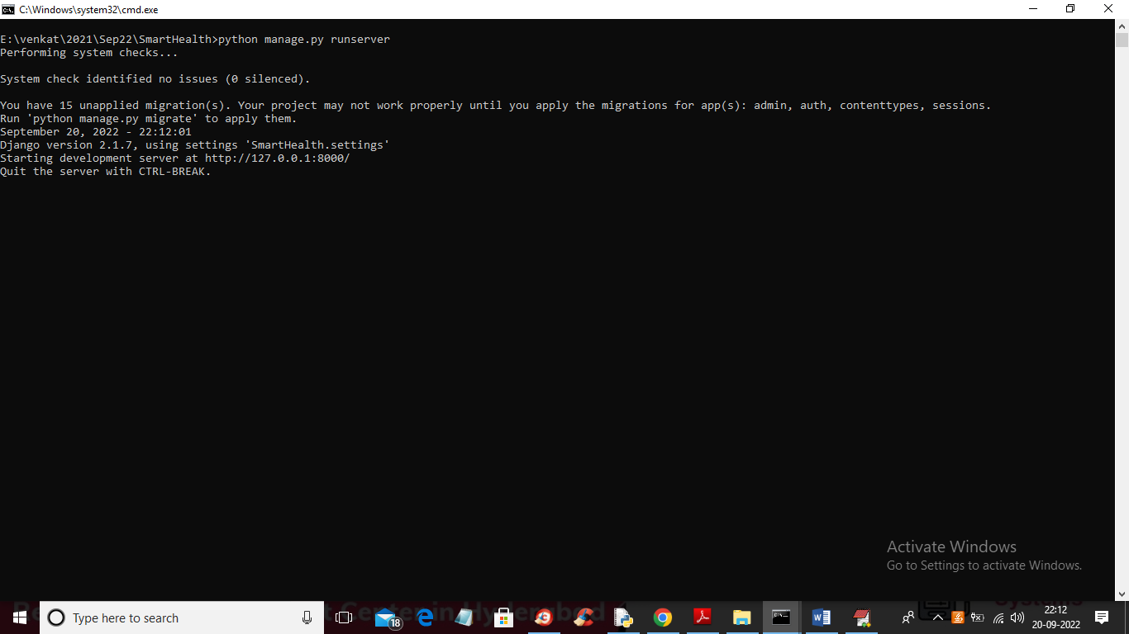

In above screen python server started and now open browser and enter URL as ‘http://127.0.0.1:8000/index.html’ and press enter key to get below page

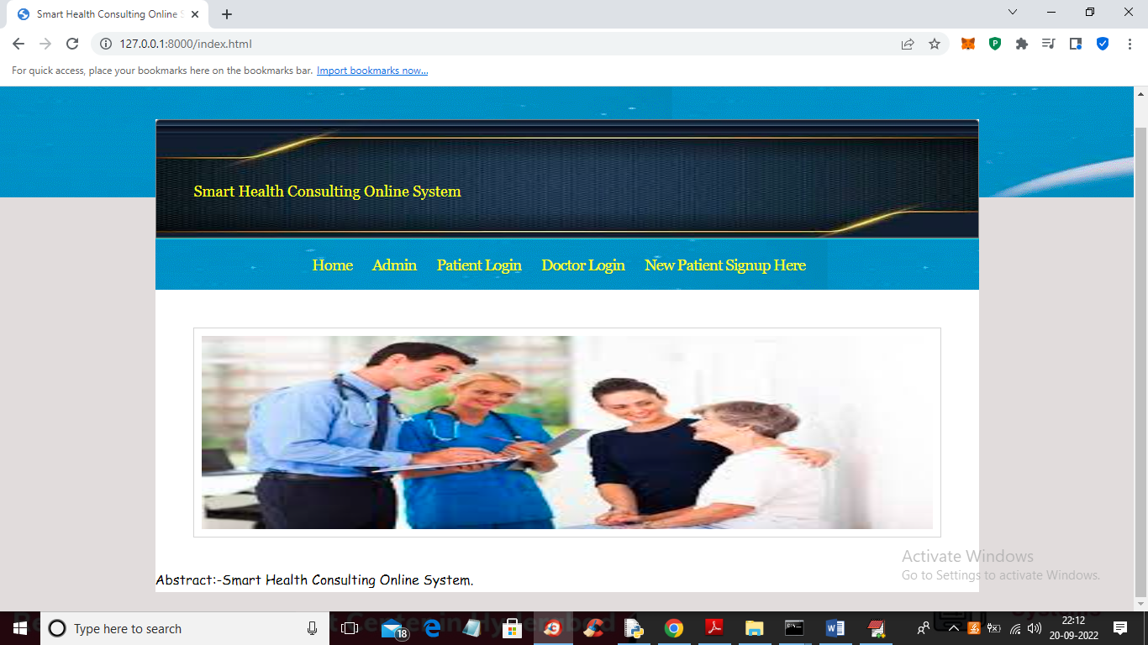

In above screen click on ‘Admin’ link to login as admin and get below screen

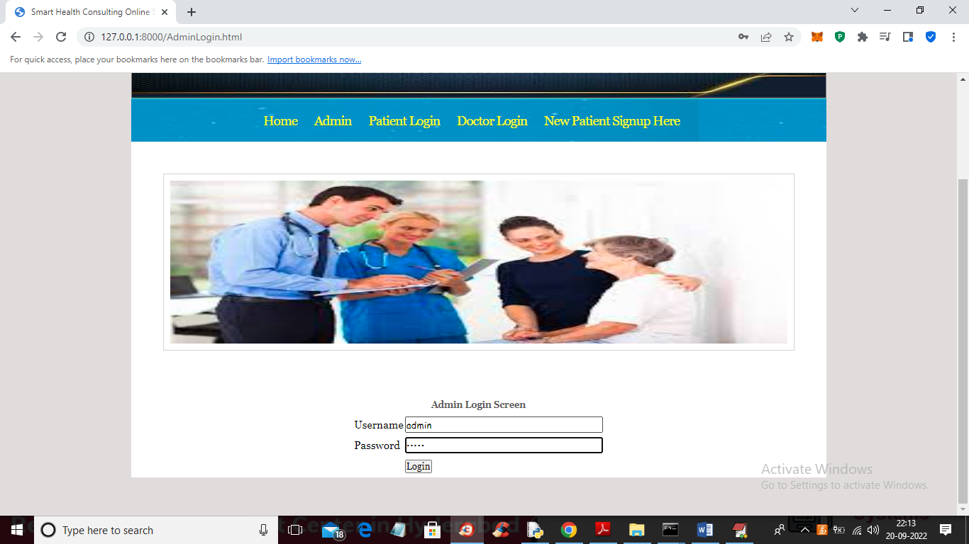

In above screen admin is login and after login will get below screen

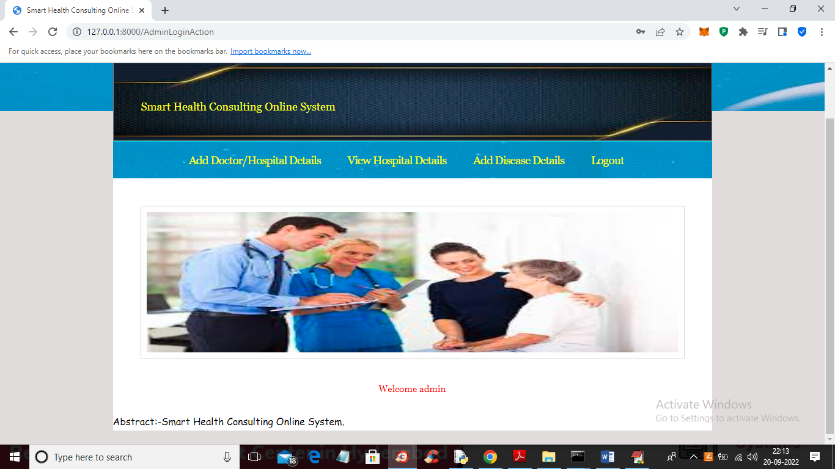

In above screen admin can click on ‘Add Doctors/Hospital Details’ link to add doctor details and get below screen

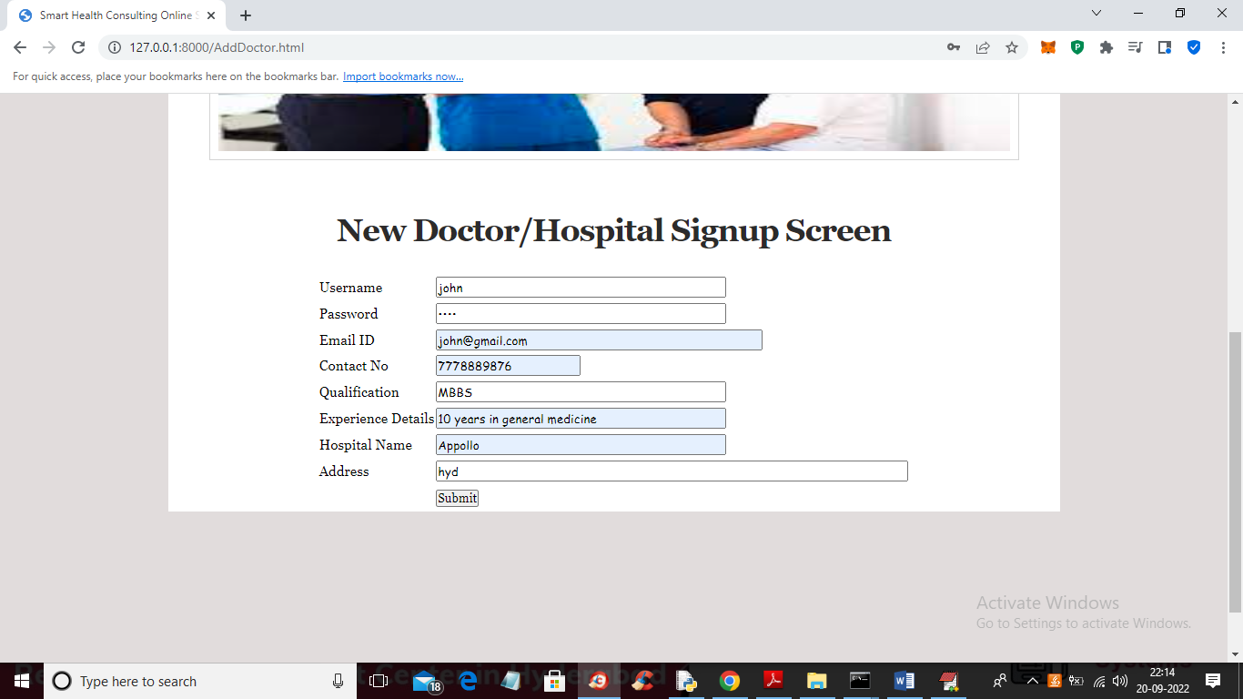

In above screen admin is adding doctor details and giving username and password and now press ‘submit’ to save record and get below output

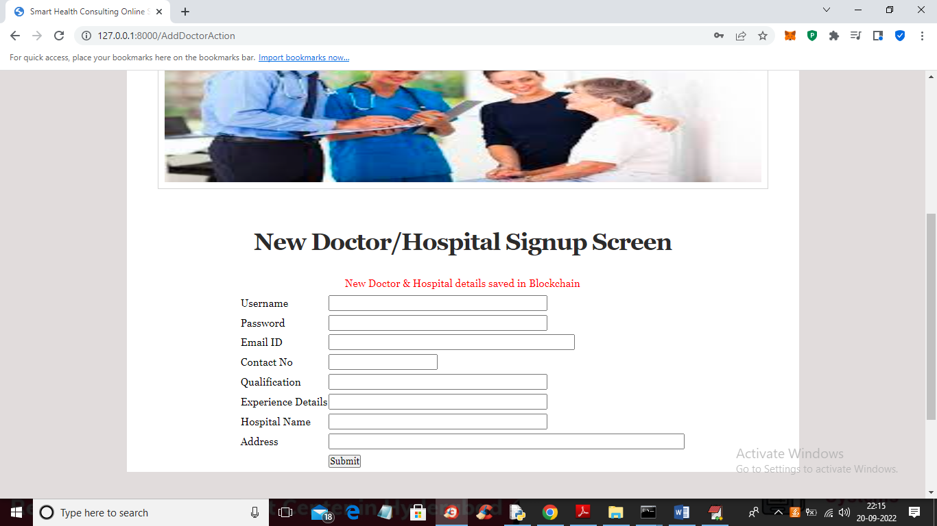

In above screen doctor details saved in Blockchain and now click on ‘View Hospital Details’ link to view all doctor details

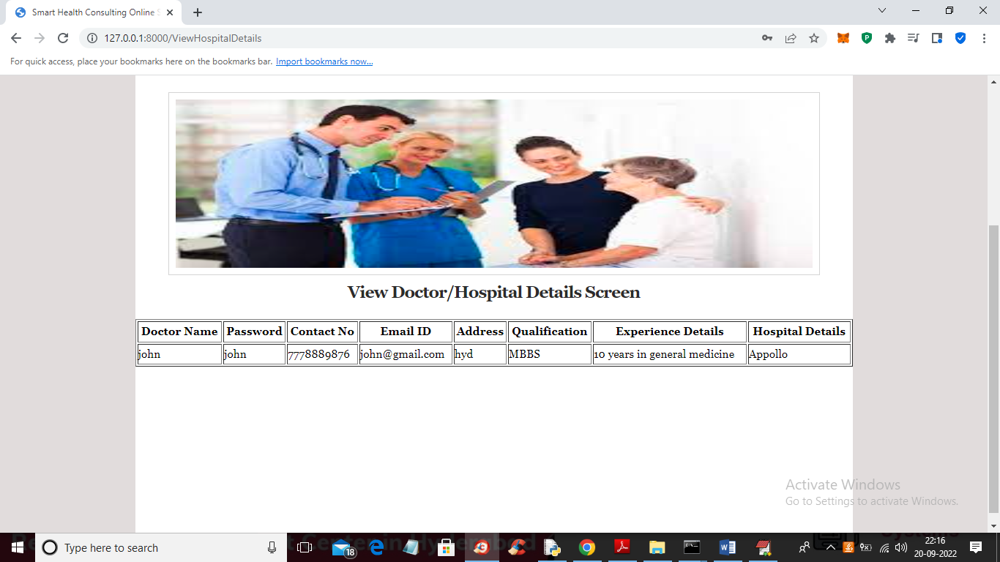

In above screen we can see doctor details and now click on ‘Add Disease’ link to add disease and symptom details

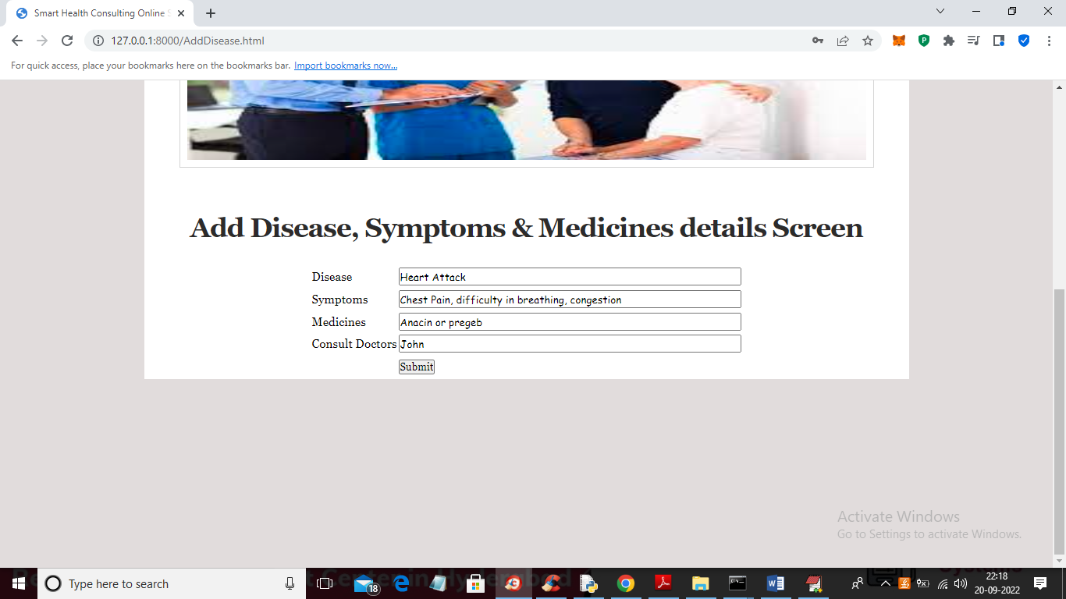

In above screen admin adding disease and symptoms and medicine details and then press button to get below output

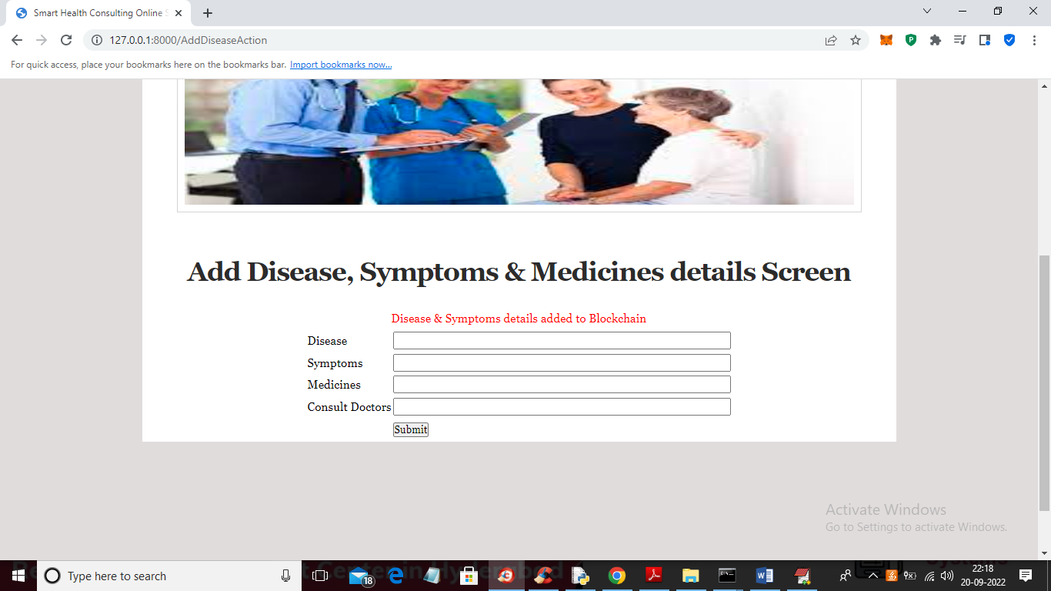

In above screen disease details saved in Blockchain and now logout and signup patient to book appointment

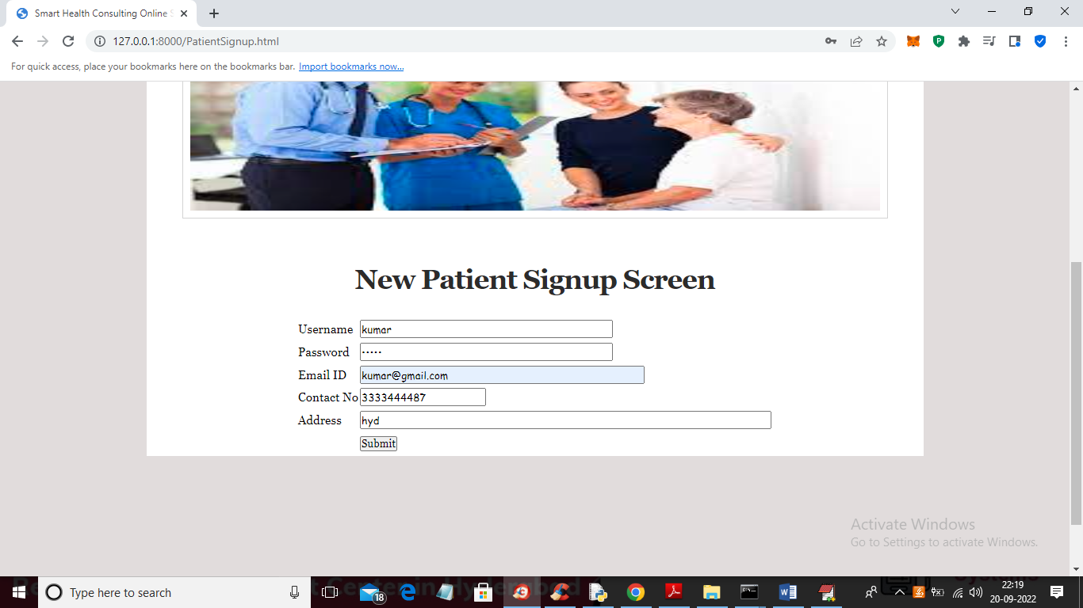

In above screen patient is entering signup details and then press button to get below output

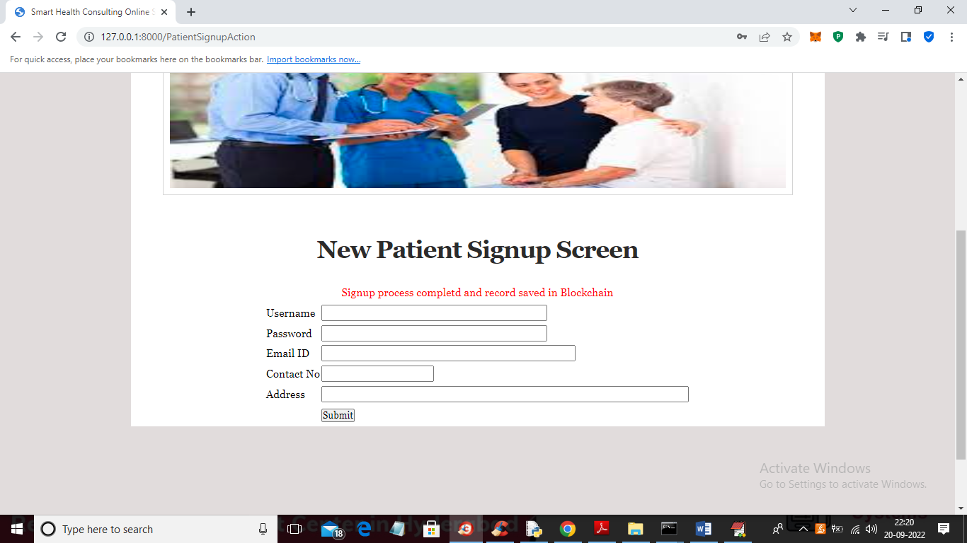

In above screen signup details saved in Blockchain and now click on ‘Patient Login’ link to login as patient

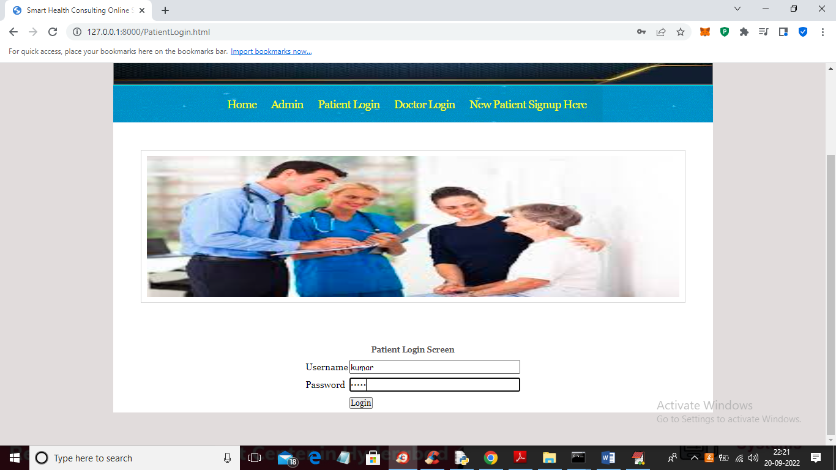

In above screen patient is login and after login will get below screen



In above screen patient can click on ‘Search Doctor’ link to search disease and doctor details

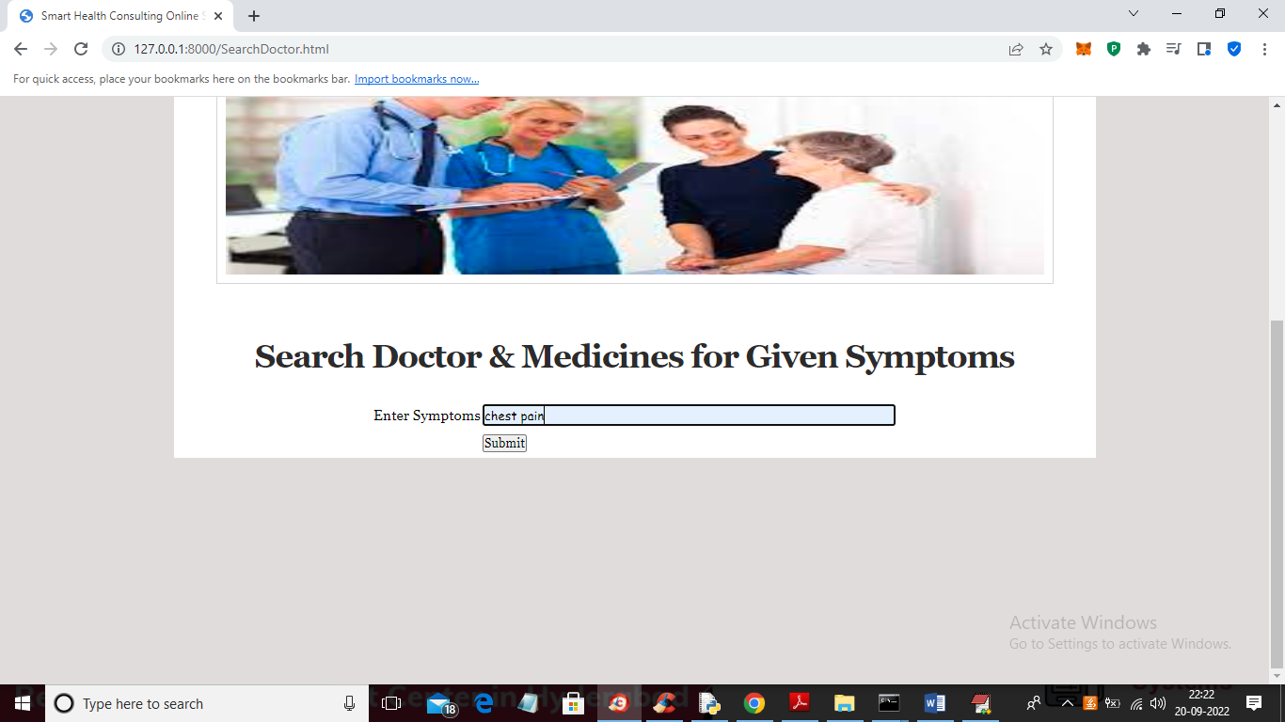

In above screen patient enter some symptoms details and then press button to get consultation doctor, medicines and disease name

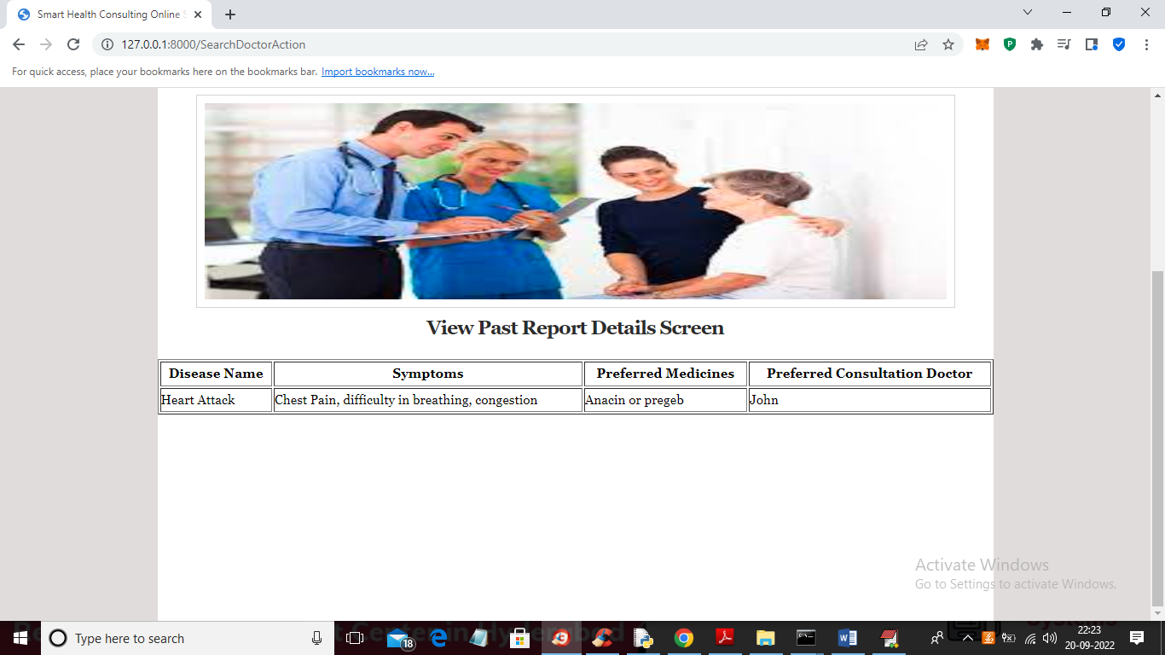

In above screen patient can view all symptoms and medicine with doctor details to consult and now click on ‘View Hospitals’ to view list of hospitals and doctors like below screen

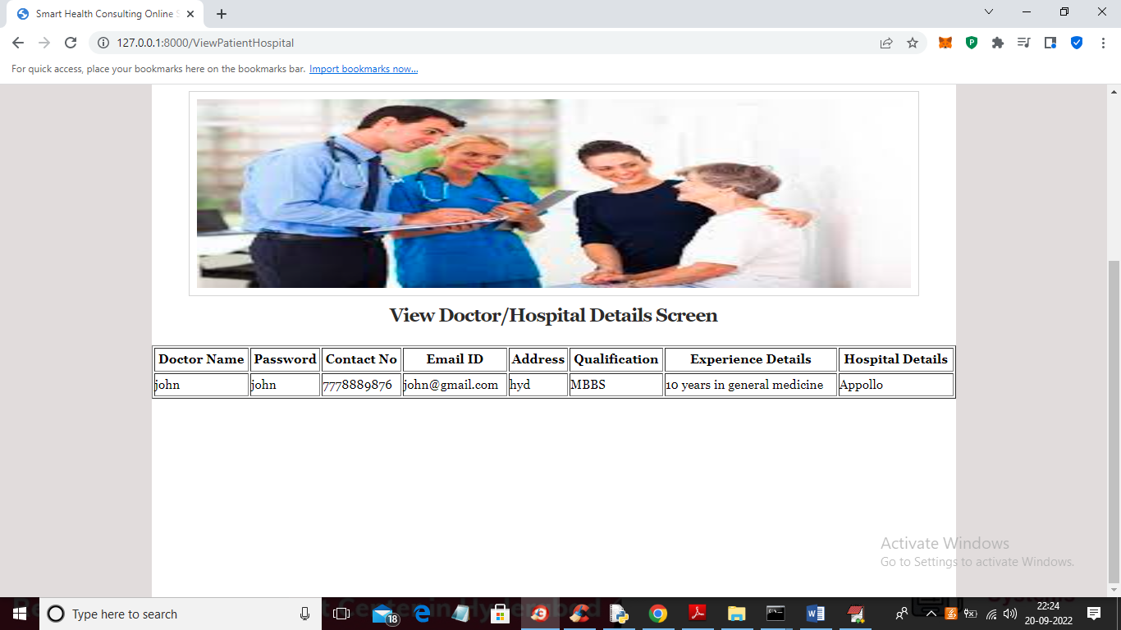

In above screen patient can view all registered hospitals and doctor details and after verifying all details and now patient can click on ‘Take Appointment’ link to take appointment like below screen

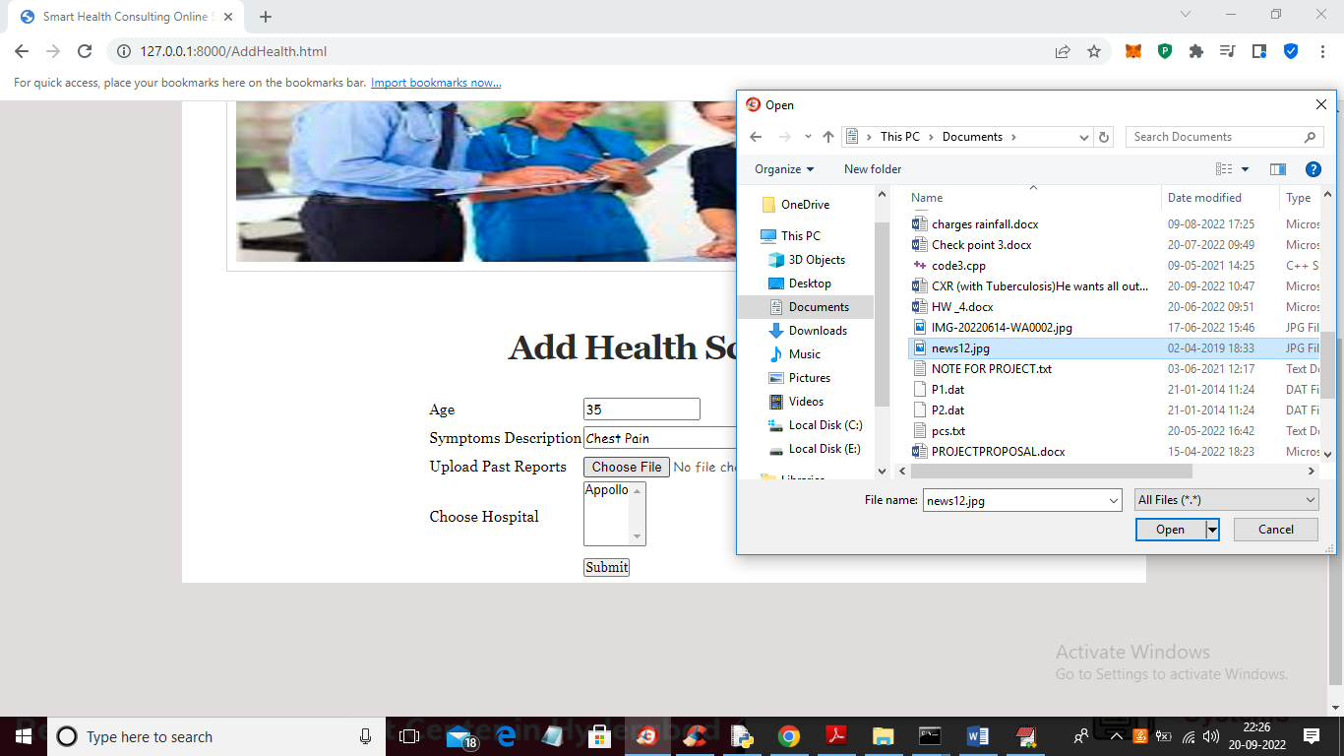

In above screen patient will enter AGE and symptoms and then upload any document of TEST reports and then select hospital name and press button to confirm appointment like below screen



In above screen we can see report and appointment confirmed with Appollo hospital and now click on ‘View Health Report’ to view prescription like below screen

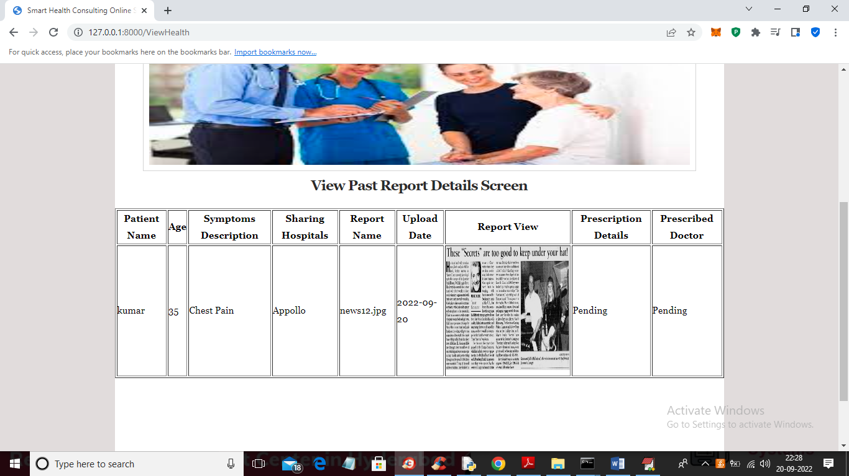

In above screen patient can view all details related to appointment and once doctor gave prescription then ‘Pending’ will update with doctor prescription and now logout and login as ‘Doctor’ to generate prescription

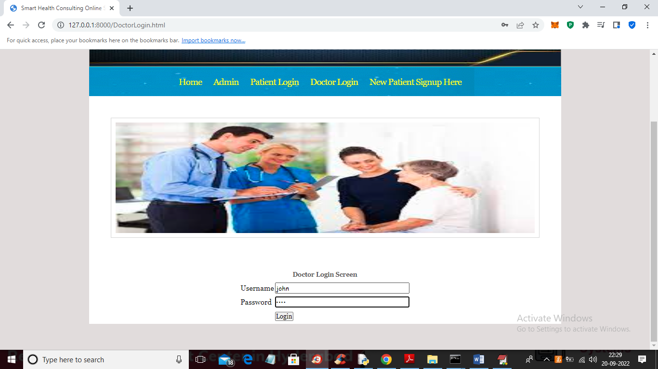

In above screen doctor is login and after login will get below screen



In above screen click on ‘View Patients Reports’ link to view appointments from patients and get below screen

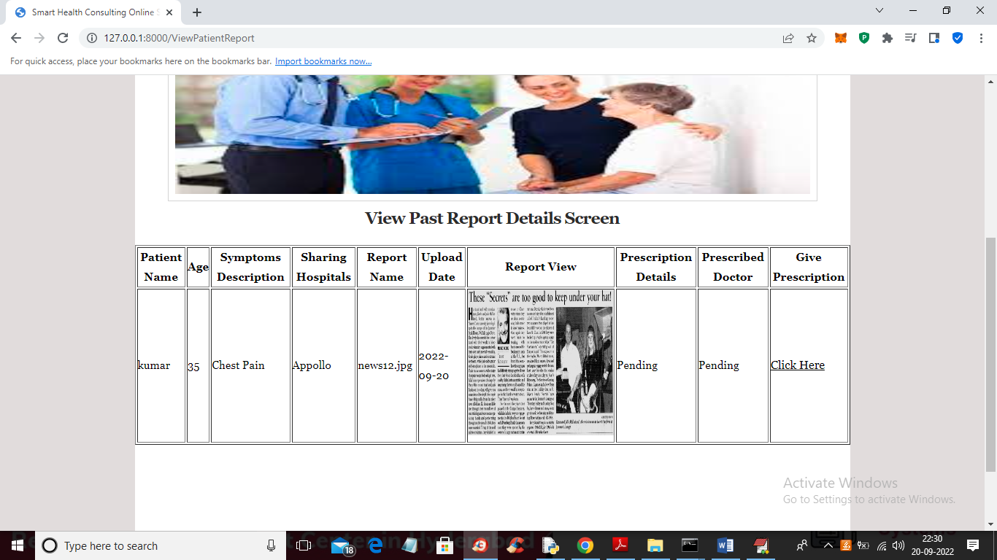

In above screen doctor will view all patient and report details and then click on ‘Click Here’ link to generate prescription and get below output

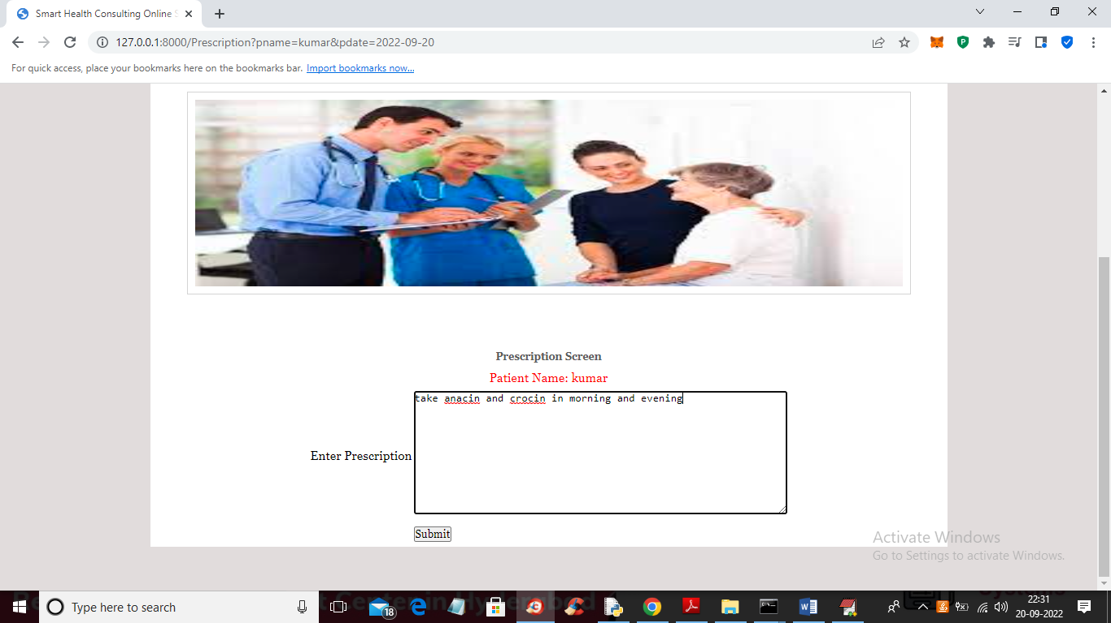

In above screen doctor is adding prescription details and then press button to get below output



In above screen we can see Prescription details added and now click on ‘View Patients Reports’ link to get below screen

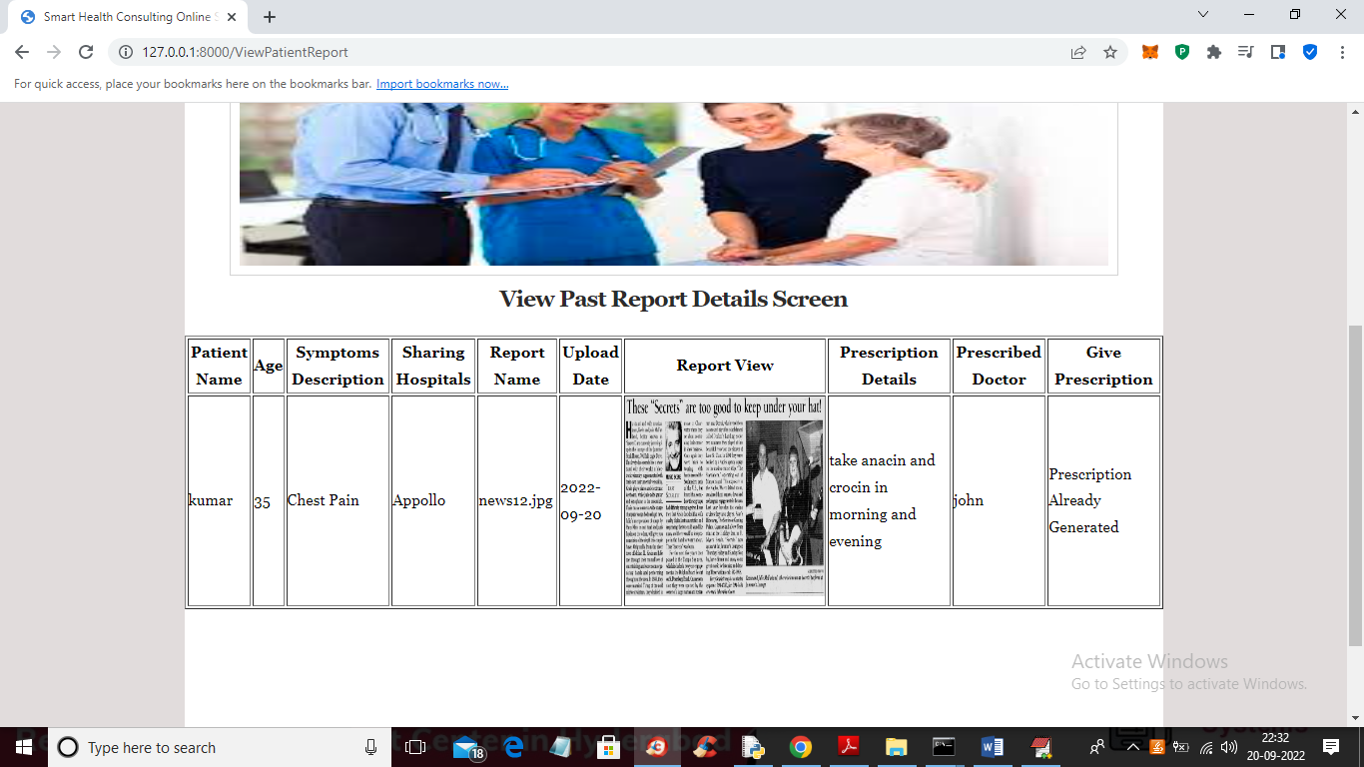

In above screen doctor can see prescription already generated and this prescription can be view by patients after login like below screen

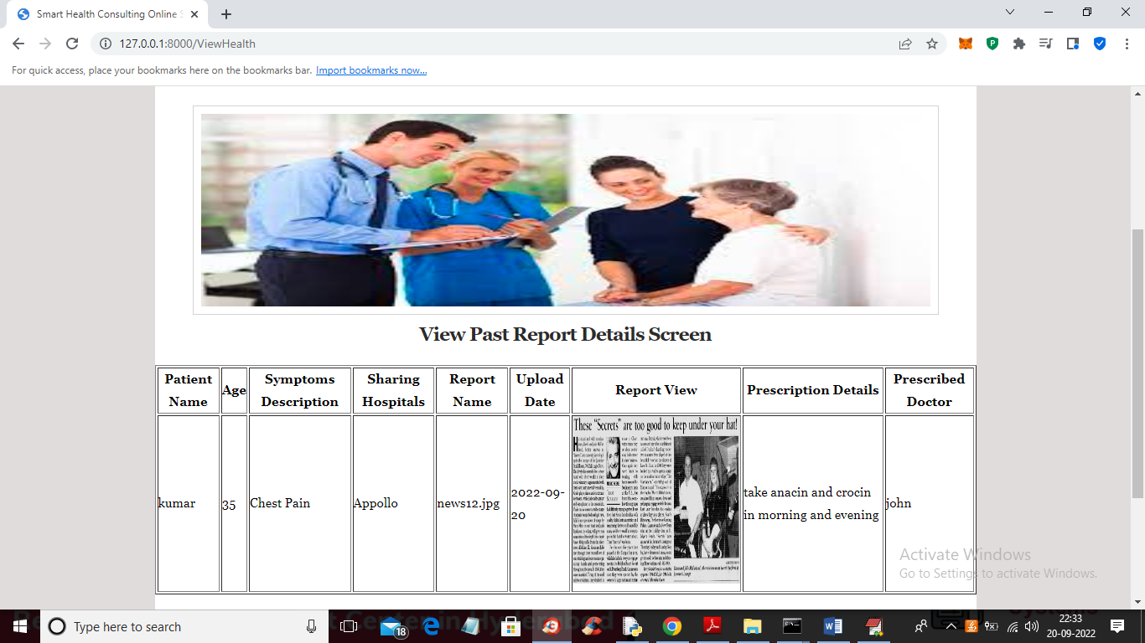

In above screen patient can view prescription and the name of doctor who prescribed this medicines

Similarly you can add any number of patients and doctors and make appointments

**CHAPTER – 8**

**SYSTEM TESTING**

The purpose of testing is to discover errors. Testing is the process of trying to discover every conceivable fault or weakness in a work product. It provides a way to check the functionality of components, sub assemblies, assemblies and/or a finished product It is the process of exercising software with the intent of ensuring that the Software system meets its requirements and user expectations and does not fail in an unacceptable mKNNer. There are various types of test. Each test type addresses a specific testing requirement.

### TYPES OF TESTS

**Unit testing**

Unit testing involves the design of test cases that validate that the internal program logic is functioning properly, and that program inputs produce valid outputs. All decision branches and internal code flow should be validated. It is the testing of individual software units of the application .it is done after the completion of an individual unit before integration. This is a structural testing, that relies on knowledge of its construction and is invasive. Unit tests perform basic tests at component level and test a specific business process, application, and/or system configuration. Unit tests ensure that each unique path of a business process performs accurately to the documented specifications and contains clearly defined inputs and expected results.

**Integration testing**

Integration tests are designed to test integrated software components to determine if they actually run as one program. Testing is event driven and is more concerned with the basic outcome of screens or fields. Integration tests demonstrate that although the components were individually satisfaction, as shown by successfully unit testing, the combination of components is correct and consistent. Integration testing is specifically aimed at exposing the problems that arise from the combination of components.

**Functional test**

Functional tests provide systematic demonstrations that functions tested are available as specified by the business and technical requirements, system documentation, and user manuals.

Functional testing is centered on the following items:

Valid Input : identified classes of valid input must be accepted.

Invalid Input : identified classes of invalid input must be rejected.

Functions : identified functions must be exercised.

Output : identified classes of application outputs must be exercised.

Systems/Procedures : interfacing systems or procedures must be invoked.

Organization and preparation of functional tests is focused on requirements, key functions, or special test cases. In addition, systematic coverage pertaining to identify Business process flows; data fields, predefined processes, and successive processes must be considered for testing. Before functional testing is complete, additional tests are identified and the effective value of current tests is determined.

**System Test**

System testing ensures that the entire integrated software system meets requirements. It tests a configuration to ensure known and predictable results. An example of system testing is the configuration oriented system integration test. System testing is based on process descriptions and flows, emphasizing pre-driven process links and integration points.

**White Box Testing**

White Box Testing is a testing in which in which the software tester has knowledge of the inner workings, structure and language of the software, or at least its purpose. It is purpose. It is used to test areas that cKNNot be reached from a black box level.

**Black Box Testing**

Black Box Testing is testing the software without any knowledge of the inner workings, structure or language of the module being tested. Black box tests, as most other kinds of tests, must be written from a definitive source document, such as specification or requirements document, such as specification or requirements document. It is a testing in which the software under test is treated, as a black box .you cKNNot “see” into it. The test provides inputs and responds to outputs without considering how the software works.

**Unit Testing**

Unit testing is usually conducted as part of a combined code and unit test phase of the software lifecycle, although it is not uncommon for coding and unit testing to be conducted as two distinct phases.

**Test strategy and approach**

Field testing will be performed manually and functional tests will be written in detail.

**Test objectives**

* All field entries must work properly.
* Pages must be activated from the identified link.
* The entry screen, messages and responses must not be delayed.

**Features to be tested**

* Verify that the entries are of the correct format
* No duplicate entries should be allowed
* All links should take the user to the correct page.

# Integration Testing

Software integration testing is the incremental integration testing of two or more integrated software components on a single platform to produce failures caused by interface defects.

The task of the integration test is to check that components or software applications, e.g. components in a software system or – one step up – software applications at the company level – interact without error.

**Test Results:** All the test cases mentioned above passed successfully. No defects encountered.

**Acceptance Testing**

User Acceptance Testing is a critical phase of any project and requires significant participation by the end user. It also ensures that the system meets the functional requirements.

**Test Results:** All the test cases mentioned above passed successfully. No defects encountered.

TEST CASES:

|  |  |  |  |
| --- | --- | --- | --- |
| **S.no** | **Test Case** | **Excepted Result** | **Result** |
| 1 | Upload the dataset images | images dataset Uploaded successfully | pass |
| 2 | Train model | Model Training  successfully | pass |
| 3 | Detect Through Image | Detection through Image successfully | pass |
| 4 | Detect Through image | Detect Through image  successfully | Image |
| 5 | Detect Through Video | Detect Through Video  successfully | pass |
| 6 | Detect Through Video | Detect Through Video  successfully | pass |
| 7 | Loss Accuracy | Loss Accuracy  successfully | pass |

**CHAPTER – 9**

**CONCLUSION AND FUTURE ENHANCEMENT**

**CONCLUSION :**

Block Chain has great importance for area of medicine, and it represents comprehensive process that demands thorough understanding of needs of the healthcare organizations. Knowledge gained with the use of techniques of Block Chain can be used to make successful decisions that will improve success of healthcare organization and health of the patients. It requires appropriate technology and analytical techniques, as well as systems for reporting and tracking which can enable measuring of results. The objective of this study is to observe the application of Block Chain, classification algorithm and feature selection methods to analyze and predict Chronic kidney disease, Heart disease and Liver disease. It can be very well analysis and predict by Block Chain and feature selection methods. From the experimental result, we observe that Block Chain, classification and feature selection methods have been used to identify, analysis and predict for chronic kidney, heart and liver diseases. Many researchers have been conducted different Block Chain, classification algorithm like ANN, Naïve Bays, SVM, Decision tree (J48, C4.5) and feature selection to improve the performance accuracy of the algorithm. Healthcare institutions that use Block Chain applications have the possibility to predict future requests, needs, desires, and conditions of the patients and to make adequate and optimal decisions about their treatments. With the future development of information communication technologies, Block Chain will achieve its full potential in the discovery of knowledge hidden in the medical data.

**FUTURE SCOPE :**

Automation of Disease Prediction x To save the environment by using paper free work. x To increase the accuracy and efficiency so that patients can get direct help. x Management of disease related data. Block Chain applications in healthcare can have tremendous potential and usefulness. However, the success of healthcare Block Chain hinges on the availability of clean healthcare data. In this respect, it is critical that the healthcare industry consider how data can be better captured, stored, prepared, and mined. Possible directions include the standardization of clinical vocabulary and the sharing of data across organizations to enhance the benefits of healthcare Block Chain applications. Further, as healthcare data are not limited to just quantitative data, such as physicians’ notes or clinical records, it is necessary to also explore the use of text mining to expand the scope and nature of what healthcare Block Chain can currently do. In particular, it is useful to be able to integrate data and text mining. It is also useful to look into how digital diagnostic images can be brought into healthcare Block Chain applications. Some progress has been made in these areas. The shift from written to electronic health records has played a huge part in the push to use patient data to improve areas of the healthcare industry.

**REFERENCES :**

[1]Boukenze, Basma, Abdelkrim Haqiq, and Hajar Mousannif. "Predicting Chronic Kidney Failure Disease Using Block Chain Techniques." In Advances in Ubiquitous Networking 2, pp. 701-712. Springer, Singapore, 2017.

[2]Ahmad, Parvez, Saqib Qamar, and Syed Qasim Afser Rizvi. "Techniques of Block Chain in healthcare: a review." International Journal of Computer Applications, Vol. 120, no. 15, 2015.

[3]Sujatha, R., and Anitha Nithya. "A Survey of Health Care Prediction Using Block Chain." International Journal of Innovative Research in Science, Engineering and Technology, Vol. 5, no. 8, 2016.

[4]Bennett, Casey, and Thomas Doub. "Block Chain and electronic health records: Selecting optimal clinical treatments in practice." arXiv preprint arXiv:1112.1668 (2011).

[5]Obenshain, Mary K. "Application of Block Chain techniques to healthcare data." Infection Control & Hospital Epidemiology, Vol. 25, no. 8 2004: 690-695.

[6] Babu, MS Prasad, M. Ramjee, Somesh Katta, and K. Swapna. "Implementation of partitional clustering on ILPD dataset to predict liver disorders." In Software Engineering and Service Science (ICSESS), 2016 7th IEEE International Conference on, pp. 1094- 1097. IEEE, 2016.

[7] Rajeswari, P., and G. Sophia Reena. "Analysis of liver disorder using Block Chain algorithm." Global journal of computer science and technology 2010.

[8] Alfisahrin, Sadiyah Noor Novita, and Teddy Mantoro. "Block Chain techniques for optimization of liver disease classification." In 2013 International Conference on Advanced Computer Science Applications and Technologies (ACSAT), pp. 379-384. IEEE, 2013.

[9] Dhamodharan, S. "Liver disease prediction using bayesian classification." In 4th National Conference on Advanced Computing, Applications & Technologies, pp. 1-3. 2014.

[10] Seker, Sadi Evren, Yavuz Unal, Z. Erdem, and H. Erdinc Kocer. "Ensembled correlation between liver analysis outputs." arXiv preprint arXiv:1401.6597, 2014.

[11] Aneeshkumar, A. S., and C. Jothi Venkateswaran. "A novel approach for Liver disorder Classification using Block Chain Techniques." Engineering and Scientific International Journal, Vol. 2, no. 1, pp. 15-18, 2015.

[12] Thangaraju, P., and R. Mehala. "Performance Analysis of PSO-KStar Classifier over Liver Diseases." International Journal of Advanced Research in Computer Engineering, 2015.

[13] Gregory, Onwodi. "Prediction Of Liver Disease (Biliary Cirrhosis) Using Block ChainTechniques." International Journal of EmergingTechnology&Research, ISSN (E) 2347-5900, 2015.

[14] Vijayarani, S., and S. Dhayanand. "Liver disease prediction using SVM and Naïve Bayes algorithms." International Journal of Science, Engineering and Technology Research (IJSETR), vol 4, no. 4, pp. 816-820, 2015.

[15] OLANIYI, EBENEZER OBALOLUWA, and KHASHMAN ADNAN. "Liver Disease Diagnosis Based on Neural Networks." Advances in Computational Intelligence , 2013.

[16] Baitharu, Tapas Ranjan, and Subhendu Kumar Pani. "Analysis of Block Chain Techniques for Healthcare Decision Support System Using Liver Disorder Dataset." Procedia Computer Science, Vol. 85, pp.862-870, 2016.

[17] Gulia, Anju, Rajan Vohra, and Praveen Rani. "Liver patient classification using intelligent techniques." International Journal of Computer Science and Information Technologies, Vol 5, no. 4, pp. 5110-5115, 2014.

[18] Ramya, Sm, and N. Radha. "Diagnosis of chronic kidney disease using machine learning algorithms." International Journal of Innovative Research in Computer and Communication Engineering, Vol 4, no. 1 , pp. 812-820, 2016.

[19] Jena, Lambodar, and Narendra Ku Kamila. "Distributed Block Chain classification algorithms for prediction of chronic-kidneydisease." International Journal of Emerging Research in Management &Technology, Vol 4, no. 11, pp. 110-118, 2015.

[20] Vijayarani, S., S. Dhayanand, and M. Phil. "Kidney disease prediction using SVM and ANN algorithms." International Journal of Computing and Business Research (IJCBR), Vol 6, no. 2, 2015.

[21] Sinha, Parul, and Poonam Sinha. "Comparative study of chronic kidney disease prediction using KNN and SVM." International Journal of Engineering Research and Technology, Vol 4, no. 12 pp. 608-12, 2015.

[22] Kumar, Manish. "Prediction of chronic kidney disease using random forest machine learning algorithm." International Journal of Computer Science and Mobile Computing, Vol 5, no. 2, pp. 24-33, 2016.

[23] Al-Hyari, Abeer Y., Ahmad M. Al-Taee, and Majid A. Al-Taee. "Diagnosis and classification of chronic renal failure utilising intelligent Block Chain classifiers." International Journal of Information Technology and Web Engineering (IJITWE), Vol 9, no. 4 pp. 1-12, 2014

[24] Kumar, Koushal, and B. Abhishek. "Artificial neural networks for diagnosis of kidney stones disease." 2012.

[25] Lakshmi, K. R., Y. Nagesh, and M. Veera Krishna. "Performance comparison of three Block Chain techniques for predicting kidney dialysis survivability." International Journal of Advances in Engineering & Technology, Vol 7, no. 1 , pp.242. 2014.

[26] Krishna, K., A. Rayavarapu, and V. Vadlapudi. "Statistical and Block Chain Aspects on Kidney Stones: A Systematic Review and Metaanalysis." Open Access Scientific Reports, Vol 1, no. 12, 2012

[27] Kunwar, Veenita, Khushboo Chandel, A. Sai Sabitha, and Abhay Bansal. "Chronic Kidney Disease analysis using Block Chain classification techniques." In Cloud System and Big Data Engineering (Confluence), 2016 6th International Conference, pp. 300-305. IEEE, 2016.

[28] Alizadehsani, Roohallah, Jafar Habibi, Mohammad Javad Hosseini, Hoda Mashayekhi, Reihane Boghrati, Asma Ghandeharioun, Behdad Bahadorian, and Zahra Alizadeh Sani. "A Block Chain approach for diagnosis of coronary artery disease." Computer methods and programs in biomedicine, Vol. 111, no. 1, pp.52-61, 2013.

[29] El-Bialy, Randa, Mostafa A. Salamay, Omar H. Karam, and M. Essam Khalifa. "Feature analysis of coronary artery heart disease data sets." Procedia Computer Science, Vol 65, pp. 459-468, 2013.

[30] Deekshatulu, B. L., and Priti Chandra. "Classification of heart disease using k-nearest neighbor and genetic algorithm." Procedia Technology, Vol.10 , pp. 85-94, 2013.

[31]Aslandogan, Y. Alp, and Gauri A. Mahajani. "Evidence combination in medical Block Chain." In Information Technology: Coding and Computing, 2004. Proceedings. ITCC 2004. International Conference on, vol. 2, pp. 465-469. IEEE, 2004.

[32] Le Duff, Franck, Cristian Muntean, Marc Cuggia, and Philippe Mabo. "Predicting survival causes after out of hospital cardiac arrest using Block Chain method." In Medinfo, pp. 1256-1259. 2004. [1] [

33] Szymanski, Boleslaw, Long Han, Mark Embrechts, Alexander Ross, Karsten Sternickel, and Lijuan Zhu. "Using efficient supanova kernel for heart disease diagnosis." In proc. ANNIE, vol. 6, pp. 305- 310. 2006.